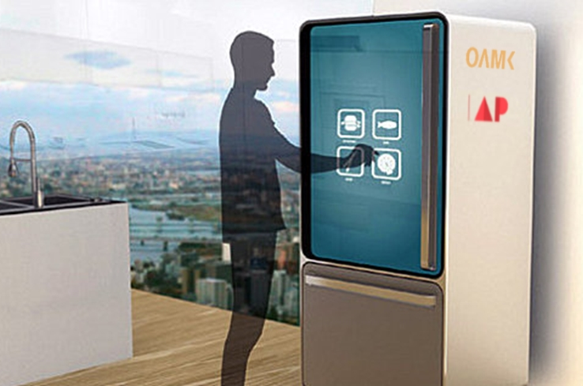

|  |  |
| --- | --- |
|  | Smart Fridge  *‘Science Fiction’ in the ‘Smart Kitchen’ - Sesam* |
|  | Tom Mampaey  Embedded system developer  Bachelor Electronics – ICT  OAMK - University of Applied Sciences - Finland  Erasmus student – Artesis Plantijn Antwerp - Belgium  January – May 2015 |

Table of contents:

1. Introduction 4

2. The project 4

3. Acknowledgements 5

4. Github 5

5. Personal information 6

6. The idea’s and brainstorm 7

6.1. User recognition: 7

6.1.1. Fingerprint reader in handheld: 7

6.1.2. Active RFID key-hanger or card: 7

6.1.3. Kinect face-recognition: 7

6.1.4. Face-recognition Raspberry-Pi: 7

6.1.5. Voice-recognition: 7

6.1.6. Motion-detection: 7

6.2. Product recognition and recommendation: Barcode-reader: 8

6.2.1. NFC-tag: 8

6.2.2. Mechanical detection/hatches: 8

6.2.3. LED’s/ LED-strip: 8

6.3. Health-detection: 9

6.3.1. Integrated scale: 9

6.3.2. Personal point-system (based on earlier snacks): 9

6.3.3. BMI-calculator: 9

6.4. Communication/Platform: 9

6.4.1. Raspberry Pi: 9

6.4.2. Arduino: 9

6.4.3. Wi-Fi and Ethernet (LAN): 9

6.4.4. Bluetooth: 9

7. Conclusion in high-level schematic 10

8. Estimated Gantt-chart: 11

9. Embedded systems 13

9.1. NFC-tags 13

9.1.1. What is NFC and how does it work 13

9.1.2. Reader and Research 13

9.2. I2C Serial Bus-System 13

9.2.1. I2C-protocol 13

9.2.2. Options 13

9.3. LED indication 14

9.3.1. Why 14

9.3.2. RGB 14

9.4. External sensors 14

9.4.1. Ultrasonic User-detection 14

SRF05 14

9.4.2. Temperature sensors 15

9.4.3. Design custom components 15

10. The Slave modules 16

10.1. The testing board 16

10.2. Final schematic 16

17

10.3. PCB design 18

10.3.1. The layers 18

10.3.2. Final PCB including ground plane 18

11. The Master module 19

11.1. Algorithms 19

11.1.1. Older versions 19

11.1.1. Serial level conversion 20

11.1.2. Final algorithm 20

11.2. Code: Mater module 21

11.3. Compose header to send 26

SendToWifi(String iD, int location, boolean Available, int temprature) 26

11.4. Serial level conversion 26

26

11.5. Schematic 26

27

11.6. PCB design 28

11.6.1. Layers 28

28

11.6.2. Final PCB including ground plane 28

12. Extension: Wi-Fi Module 29

12.1. CC3000 module 29

12.2. Code 30

12.2.1. GetContentByFilterOn 34

12.2.1. SendToServer 34

12.3. Response of server and ping 35

12.3.1. Ping to server 35

13. Custom Printed Circuit Boards 36

13.1. Test boards 36

13.1.1. Problem solving 36

13.2. Surface Mounted Device (SMD) 36

13.3. Start 37

13.4. Chemicals 37

14. 3D modulating & printing 38

14.1. The design and software 38

14.2. The Printers 39

14.2.1. Stratasys Fortus eV 39

14.2.1. Details 39

14.3. Result, production, assembly 40

15. Personal project evaluation 40

15.1. What I learned 41

15.2. Distribution of subjects 42

16. Optimalisations and further extensions 42

Blijven optimaliseren 42

17. Of-topic: 43

18. Concise self-evaluation 43

Annex: 44

Content: 44

Datasheets: 44

Images: 45

Supplementary component list: 46

1. Introduction

Allow me to introduce myself. I’m Tom Mampaey, third-year student from ‘Artesis Plantijn Antwerp’ in Belgium. When I saw the opportunity to go on Erasmus to Oulu in Finland and do my Bachelor's project there I did everything to make it possible. I made this project in cooperation with Bernd Verhofstadt. We are very thrilled about what we have accomplished.

1. The project

The project we worked on was a daughter-project of a bigger project. The premise was to put some intelligence into the ordinary kitchen (Sesam), within a time frame of two years. We have had the privilege to be the first two students to contribute to this project.   
As stated in the title, our share of the project related specifically to the smart refrigerator. Imagine the possibilities when your refrigerator knows more about you, your habits and your day-to-day products. You could find recipes for the specific ingredients in your refrigerator, or learn more about the healthy choices, and wouldn't it be great to have the contents of your fridge in your pocket when grocery shopping? This and more is what we envisioned for the kitchen of the future. The general idea was to make a refrigerator that will know who’s using it, what he may or may not eat and even what’s in the refrigerator. The refrigerator will base its knowledge on the current properties of the user, such as weight, length, through User-input, Readers, BMI-calculator, etc.

*This project was set up with the purpose of having a realistic and practical end result.*

1. Acknowledgements

*Project managers:*   
**Mr. Jussi Kangasoja**  
✉ [Jussi.Kangasoja@oamk.fi](mailto:Jussi.Kangasoja@oamk.fi)

**Ms. Kaisa Orajärvi**  
✉ [Kaisa.orajarvi@oamk.fi](mailto:Kaisa.orajarvi@oamk.fi)

*Hardware subvention:***Mr. Henry Hinkula**   
✉ [*Henry.Hinkula@oamk.fi*](mailto:Henry.Hinkula@%6f%61%6d%6b%2e%66%69)

*Belgian Lectors:***Mr. Jeroen Doggen**✉ [*Jeroen.doggen@ap.be*](mailto:Jeroen.doggen@ap.be)

**Mr. Tim Dams**✉ [*Tim.dams@ap.be*](mailto:Tim.dams@ap.be)

1. Github

To maintain the structure, workflow and to easily monitor the project we have made a repository on Github for this project. As requested by our project managers the Git is public for further enhancements in the future by other international students.   
You can find the repository on:   
<https://github.com/OAMK-Smart-Kitchen/Smart-Fridge-OAMK>

1. Personal information
2. The idea’s and brainstorm

Because we only got a title, and a few start-ideas, of the project we were totally free implement the technologies and features in the fridge that we wanted. This gave us a lot of freedom, but also took a lot of time for research , brainstorming, achievable/serviceable technologies and thinking about what would be handy and what the user would like to have extra in his/her fridge at home.

* 1. User recognition:
     1. Fingerprint reader in handheld:

|  |  |
| --- | --- |
| **PRO** | **CONTRA** |
| Very unique (for each person) | You have to touch something |
| Reliability | Difficult with wet fingers |
|  | Waiting-time |

* + 1. Active RFID key-hanger or card:

|  |  |
| --- | --- |
| **PRO** | **CONTRA** |
| Detection on distance | Physical object |
| Multiple use and handy | Can mix up multiple users |
| Cheap |  |

* + 1. Kinect face-recognition:

|  |  |
| --- | --- |
| **PRO** | **CONTRA** |
| Challenging | Delay |
| Automatic recognition | Height of camera |
| International team-work | Complex |

* + 1. Face-recognition Raspberry-Pi:

|  |  |
| --- | --- |
| **PRO** | **CONTRA** |
| Automatic recognition | Delay |
| Cheap | Height of camera |
|  | Reliability |

* + 1. Voice-recognition:

|  |  |
| --- | --- |
| **PRO** | **CONTRA** |
| Accessibility | Complex |
| Cheap | Reliability |
| Fun |  |

* + 1. Motion-detection:

|  |  |
| --- | --- |
| **PRO** | **CONTRA** |
| Energy-saving (only on when motion) | No direct user-recognition |
| Cheap | Reliability |
| Easy |  |

* 1. Product recognition and recommendation:  
       
     Barcode-reader:

|  |  |
| --- | --- |
| **PRO** | **CONTRA** |
| Existing databases | Finding a fast way to scan it |
|  | By hand |
|  | Takes time |

* + 1. NFC-tag:

|  |  |
| --- | --- |
| **PRO** | **CONTRA** |
| Wireless | Attach on the products/tray |
| Stickers are cheap | Reader on every place |
| Place-independent |  |

* + 1. Mechanical detection/hatches:

|  |  |
| --- | --- |
| **PRO** | **CONTRA** |
| Overview and organization | Moving parts |
| Reliability | Expensive |
| Not possible to take other product |  |

* + 1. LED’s/ LED-strip:

|  |  |
| --- | --- |
| **PRO** | **CONTRA** |
| Clearly what product it is | User can take other products. |
| Colors for good and bad |  |
| Fancy |  |

* 1. Health-detection:
     1. Integrated scale:

|  |  |
| --- | --- |
| **PRO** | **CONTRA** |
| User-assuredness | Big surface-area |
| Possibility to calculate BMI | View |
| No extra action required (for user) |  |

* + 1. Personal point-system (based on earlier snacks):

|  |  |
| --- | --- |
| **PRO** | **CONTRA** |
| Motivating for users | Requires many properties of user |
| Competitive |  |
| Possibility to turn off feature |  |

* + 1. BMI-calculator:

|  |  |
| --- | --- |
| **PRO** | **CONTRA** |
| Easy calculation | Requires (many) properties of user |
| User can compare to average | Frustrating |
| Possibility to turn off feature |  |

* 1. Communication/Platform:
     1. Raspberry Pi:

|  |  |
| --- | --- |
| **PRO** | **CONTRA** |
| Performance | Limited hardware ports |
| All-in one computer |  |
| Internet-connection |  |

* + 1. Arduino:

|  |  |
| --- | --- |
| **PRO** | **CONTRA** |
| Perfect test-device | No internet-connection |
| Many possibilities | Limited hardware-set |
| Cheap |  |

* + 1. Wi-Fi and Ethernet (LAN):

|  |  |
| --- | --- |
| **PRO** | **CONTRA** |
| Connected devices | Security |
| Software updates |  |
| Monitoring |  |

* + 1. Bluetooth:

|  |  |
| --- | --- |
| **PRO** | **CONTRA** |
| Peer-to-peer | Not always reliable |
| Not connected to the internet | Possible delays |
|  | Can only connect 2 devices at once |

1. Conclusion in high-level schematic

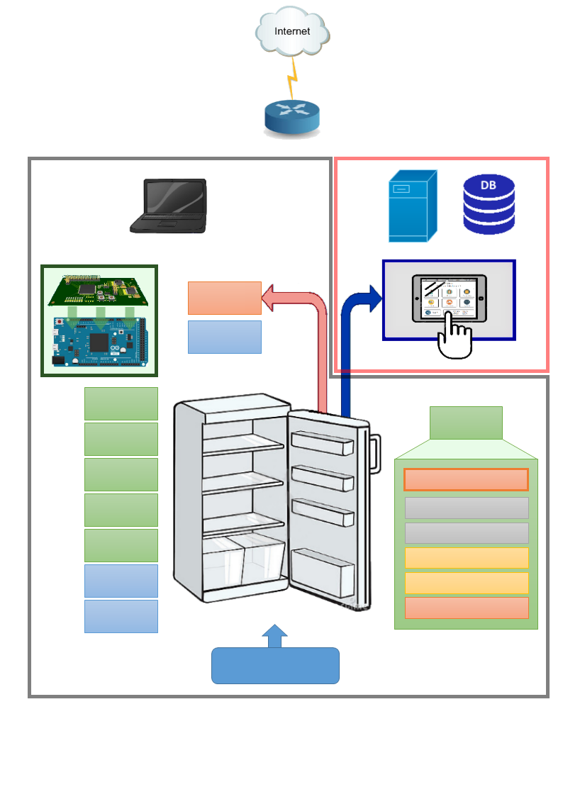After lots of research and discussing about what are the best technologies, and what is realistic in this amount of time we came up with this as the best starting idea:

**...**   
Up to 127 different devices on the same I2C-bus.

(Serial) Level - convertion

RGB - LEDSTRIPS

Addressing + LED driver

NFC reader

Addressing + NFC driver

I2C - Protocol

**Products with NFC-tags**

**Product   
Module 5**

**Product   
Module 4**

**Product   
Module 2**

Server Database

**UI/Server side**

**Embedded side**

**Product   
Module**

Temp. IN 2

Temp. IN 1

**Product   
Module 1**

**Product   
Module 3**

Temp. Out

Motion sensor

Tablet

Custom PCB + DUE

Computer

Router

1. Estimated Gantt-chart:



1. Embedded systems

As the embedded system developer I had to figure out which components, set-up, technologies and systems were most appropriate for this application and for extensions in the future.

* 1. NFC-tags

After lots of research of the different possibilities I found some articles on the internet that we are considering to replace barcodes on products by NFC-tags to make it much more user-friendly and the more research I did the better this technology got.

* + 1. What is NFC and how does it work

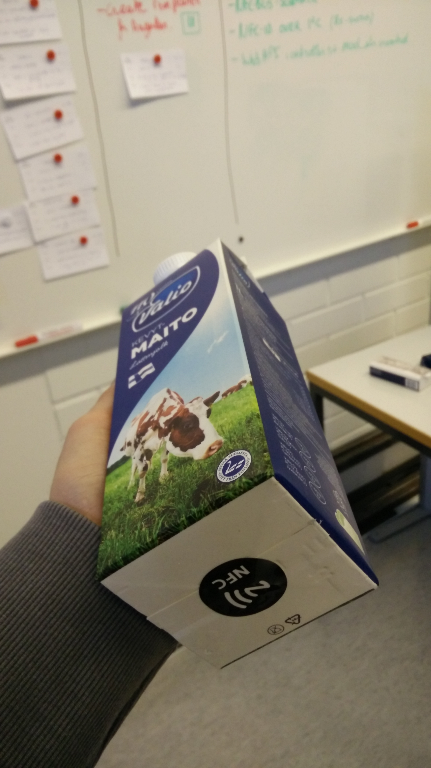

NFC stands for **N**ear **F**ield **C**ommunication and allows phones, tablets, and laptops to share data with other NFC-equipped devices. The technology evolved from radio-frequency identification (RFID) tech. RFID

* + 1. Reader and Research
  1. I2C Serial Bus-System
     1. I2C-protocol

Adresses  
I2C( zie datasheet SC16IS750: p 37 to 40 SCL SDA,... en PCF)

I2C, bit van adress doen omdat Wire-lib werkt met 7 bits (schrijf en leesbit wegdoen) zodat het onder 124(?) blijft

<http://playground.arduino.cc/Main/WireLibraryDetailedReference>

Alle mogelijke devices aan verbinden.

I2C- BUS (serial connection, two little wires, control them all!) up to 127 devices (more then products fit in your fridge)  
Beautiful thing about is that you can now add any device you want (temp, calorimeters, product alarms, YOU NAME IT!)

I2C protocol, serial connection over two little wires where i can control up to 127 different divives (even more than different products that fit in tour fridge). Can be any device (tempssensor, lightcontrol, locks (pin), ..

* + 1. Options
  1. LED indication
     1. Why
     2. RGB

Ex. Custumize colors, reserve products,

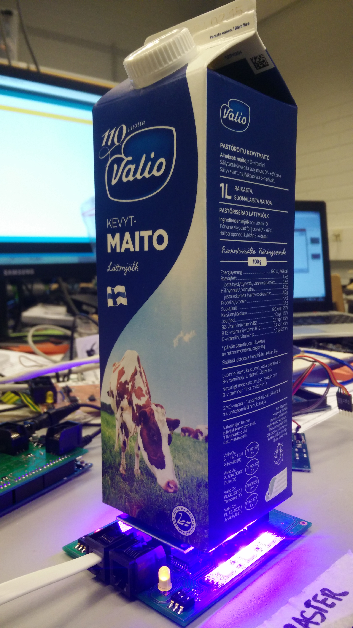

* 1. External sensors
     1. Ultrasonic User-detection

To detect if there is a user in front of the fridge I use ultrasonic sensors.

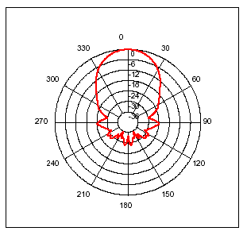SRF05

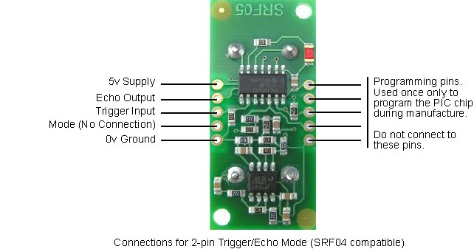

* + 1. Temperature sensors
    2. Design custom components

Eagle

LEDS,

1. The Slave modules

The first, and one of the important parts was to accomplish the slave-boards.   
They will indicate the products with the RGB-strips and read and send them to the master.  
The slave boards are capable to:

* Communicate with the master module by I2C-protocol
* Adopt the data of NFC-tag and send it over serial line
* Give visual indication when reading
* Close sending port when not reading
* Drive RGB LED by demand of master module
* Approachable by an address for NFC-reading
* Approachable by an address for LED-indication
* Be failure proof
  1. The testing board

After lots of research, coding, ups and downs I made the first testing board.   
This board is the first step in the direction of a working prototype.

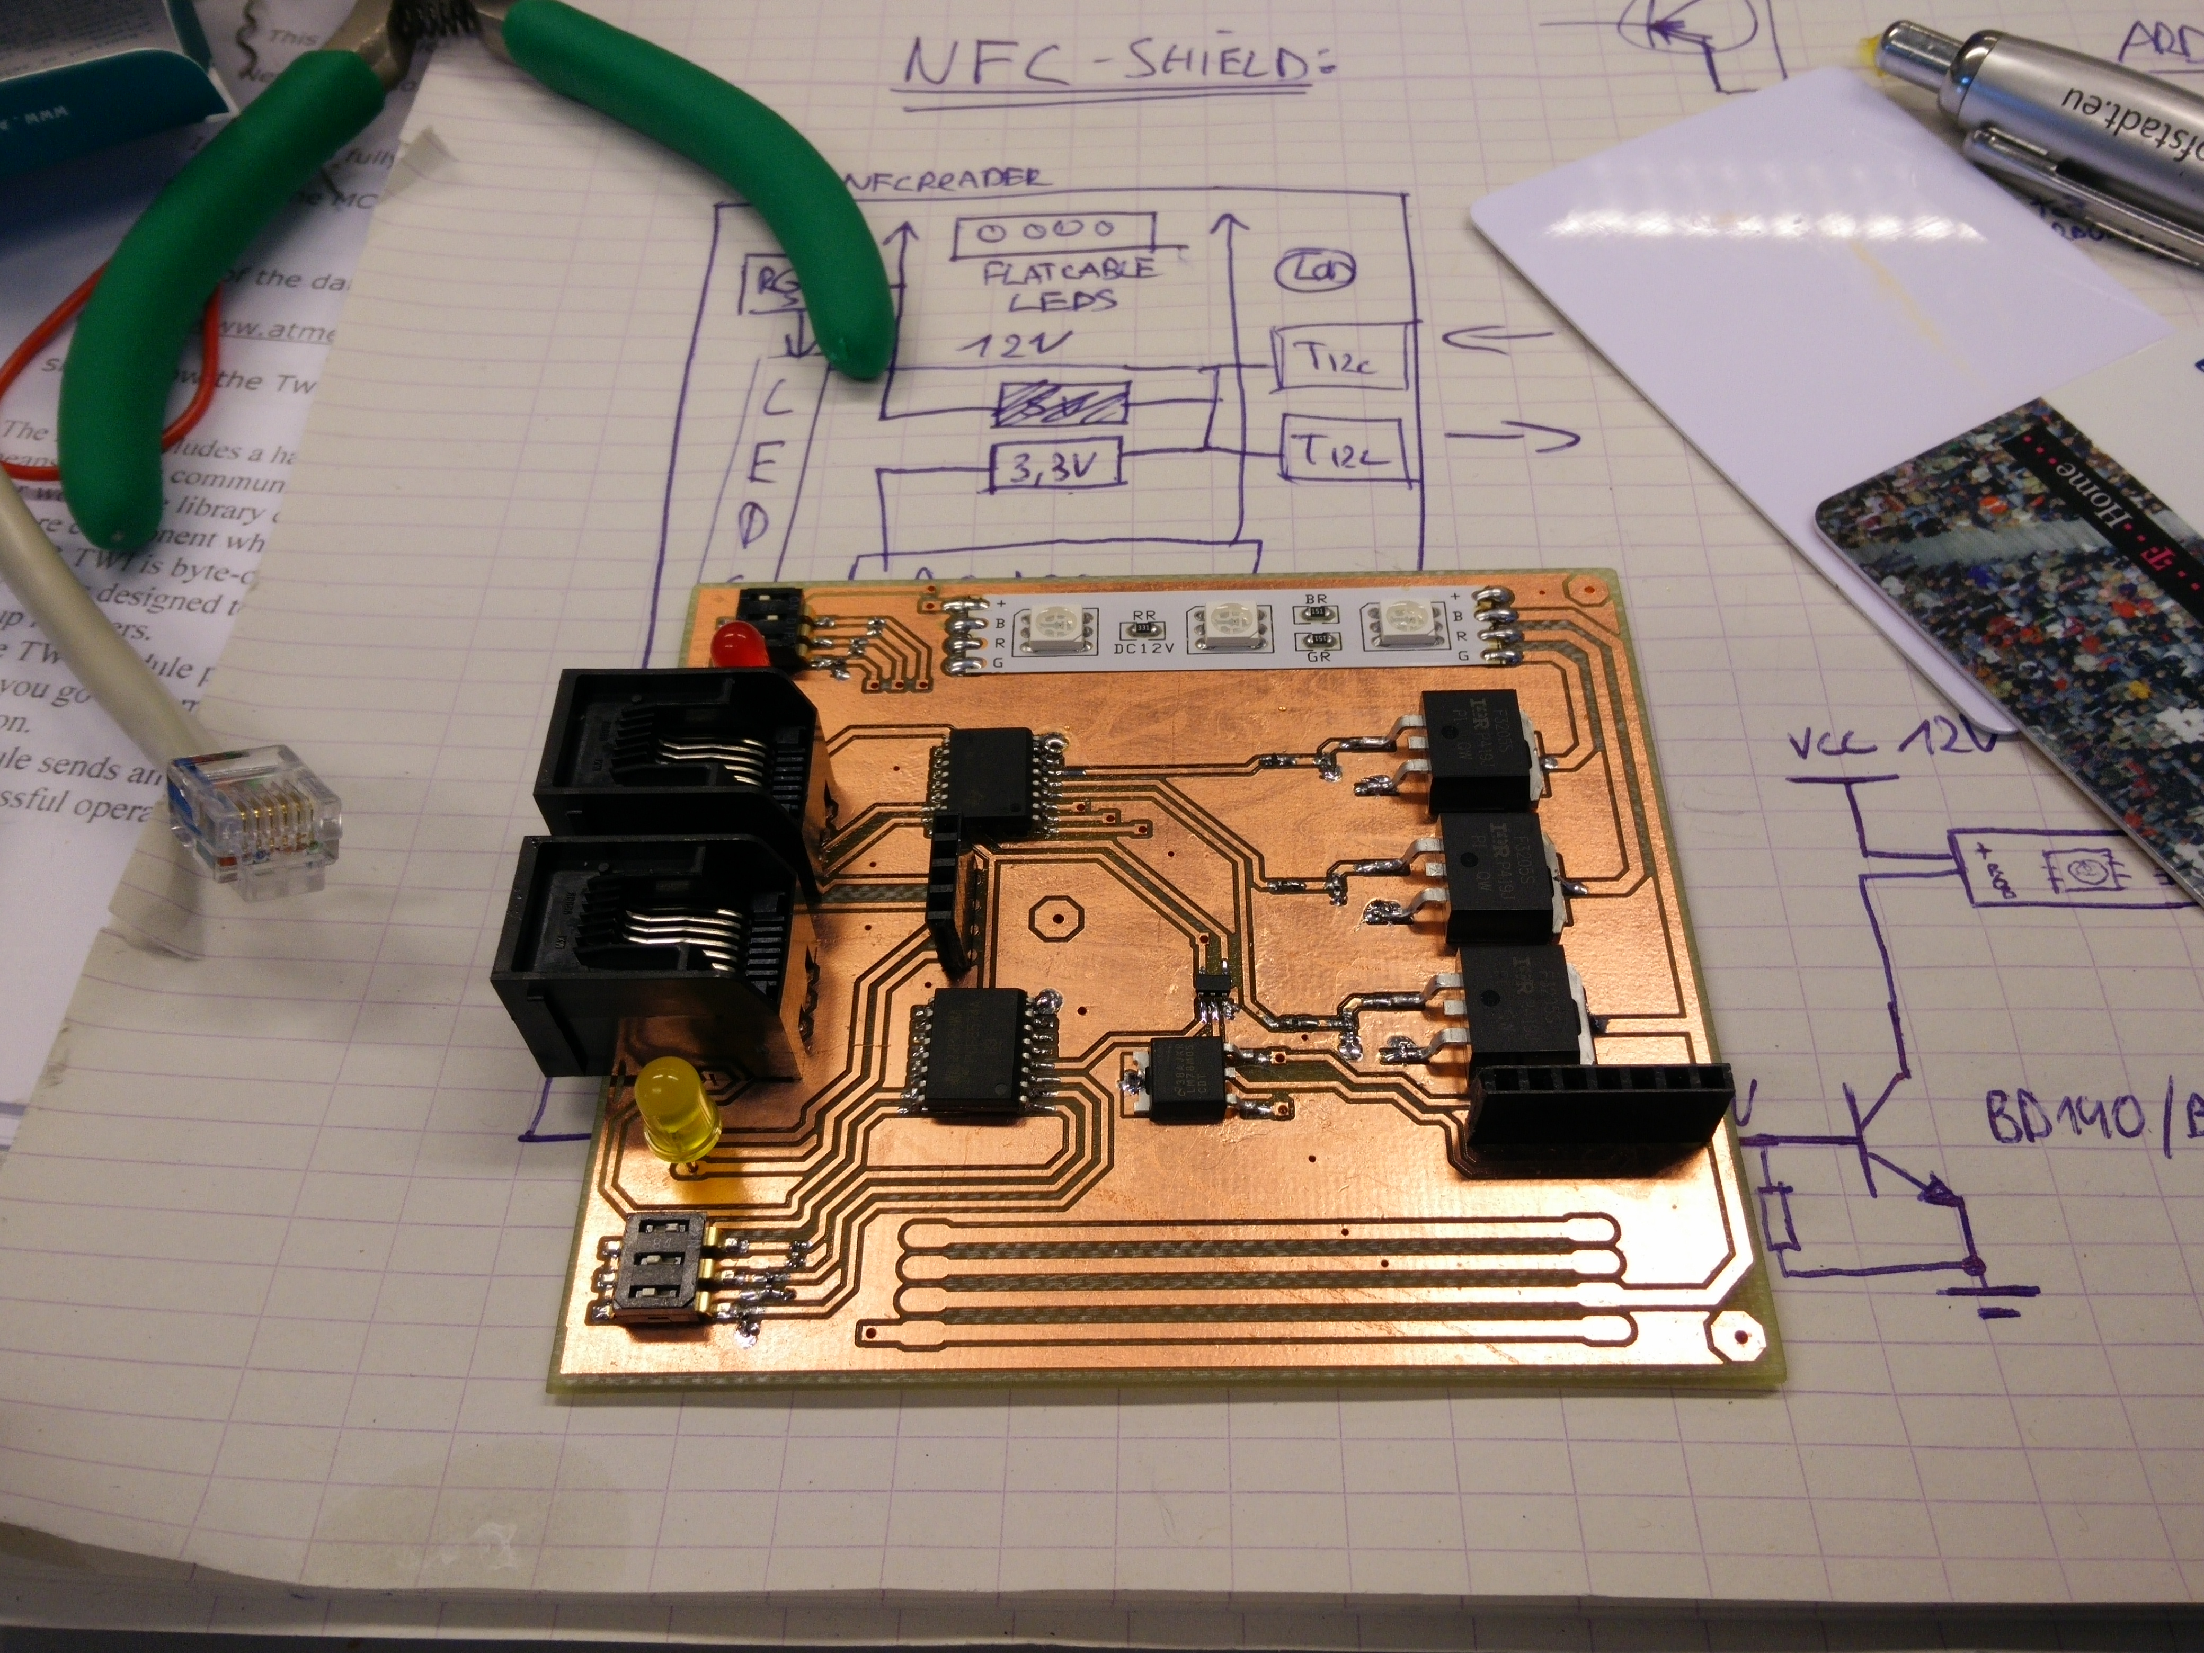

It’s always a good idea to make test board like this ones. Your components are already on the right place, faults can be measured, no interference or bad connections due breadboards etc. Due this board I found a lot of problems and interferences I didn’t thought about before.

When this board was fully assembled and finally without interferences and burning components I could start optimal sing the board and schematic to start coding again!

* 1. Final schematic
* Unfold next page (A3-size)

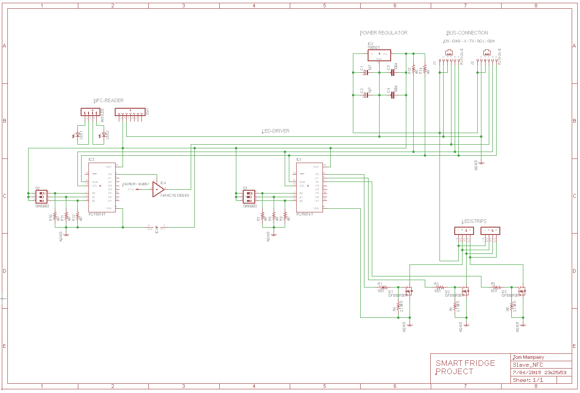

* 1. PCB design

When I triple checked the schematic, components and connections between them it was time to design the final PCB-board. To put the performance to the maximum and interferences to the minimum it’s important to:

* Place this components on very strategic places
* Make the ground plane as large as possible
* Put the filter capacitors as near as possible to the supply lines
* Use large pads and diagonal wire bend for optimum connection
* Never put radiating/electrostatic/sensitive/high-current components together
  + 1. The layers

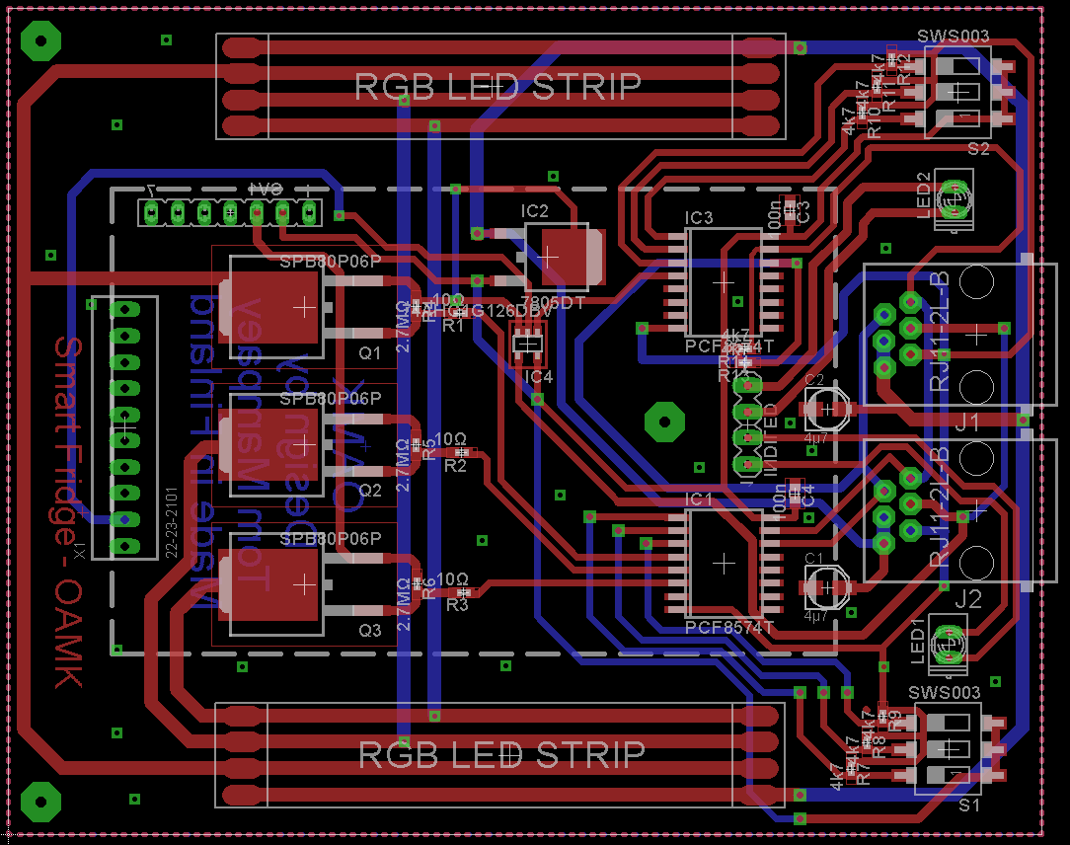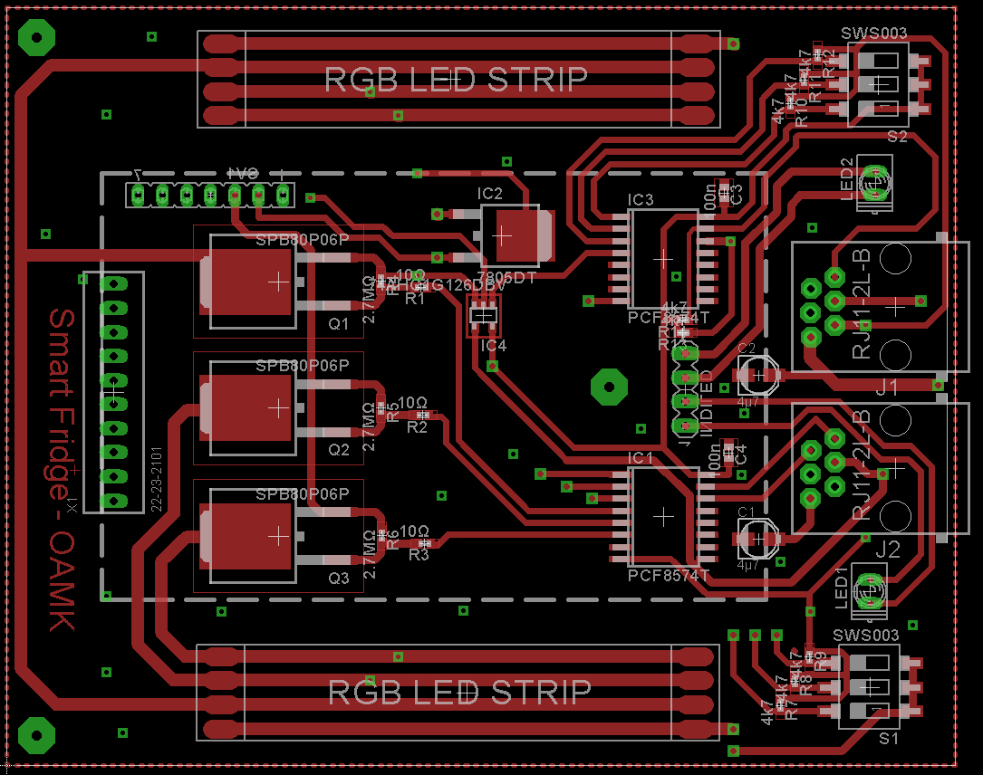The striped line is where the NFC-board will be connected.   
 *Main (/top) layer Added second (/bottom) layer*

* + 1. 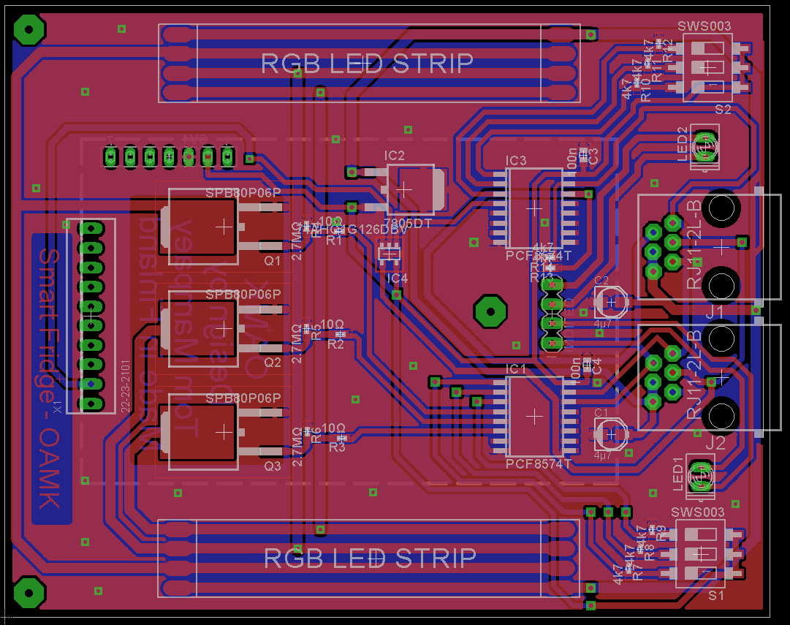Final PCB including ground plane

Pull-down lines

Set Reader Address

Read indication LED

I2C connectors

Power LED

RGB indication 1

Capacitive reg.  
8-bit I/O expanders Voltage regulator

Tri-state serial Switch

NFC-input

LED driver circuit  
  
Peak filters (cap.)  
  
RGB indication 2

Set LED Address

1. The Master module

The master module is actually the brain of the fridge and controls the whole system.   
It communicates with all the connected devices, NFC-readers, sensors, etc. After the necessary calculations/translations it processes the data and sends it to the output-port.  
The master board is based on an Arduino Mega/Due and operates as a shield.

The master board can:

* Open the serial TX-line by commanding the slave module by (serial switch) address
* Read and translate the incoming date of the slave modules on the RX-line
* Control the seven LED-colors of every individual module by (LED driver) address
* Control up to 127 devices connected to the I2C-bus
* Translate and process the data and send it in a header to the output-port
* Convert the voltage level on the serial line from 5 to 3.3 when in use with DUE
* Filter interferences and power the whole (control) system.
* Give you the option to switch the serial lines of the output-port by a jumper
* Read the temperature outside of the fridge
* Read the distance of a user in front of the fridge and interact by it.
  1. Algorithms

Because the datasheet of the reader module is very limited I had to figure out by myself how to get values out of the tag and find an appropriate and stable algorithm that converts the data coming from the NFC-reader to an ID. This was defiantly one of the most time swallowing things.

* + 1. Older versions

Before I finally got a good algorithm already many came before them. From filtering on the brand of the tag (first characters) to reading the first 40 chars when the reader detects a tag.

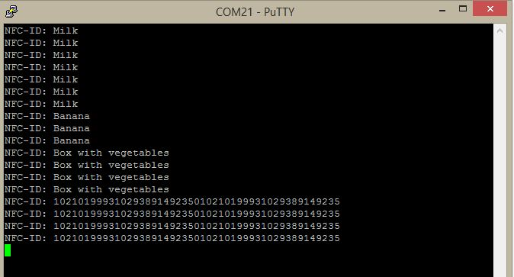Sometimes the incoming data was completely random, otherwise the data where only two chars. Always when I thought I had a good one, there was always something else getting in the way why I had to find a new algorithm again e.g. baudrates, serial level, output-pin,…  
Many commits on git can confirm this.

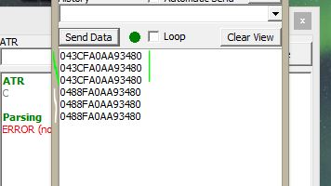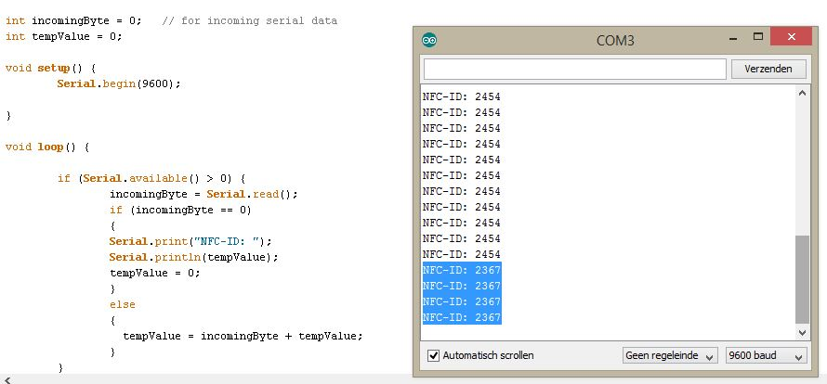

* + 1. Serial level conversion

A top reason why I had to change the algorithms so much is mainly because of the unstable output on the RS232 pin of the NFC-reader. It became clear that I had to convert the serial level in order to not fry fragile components with uart voltage peaks of (+~-) 10V.

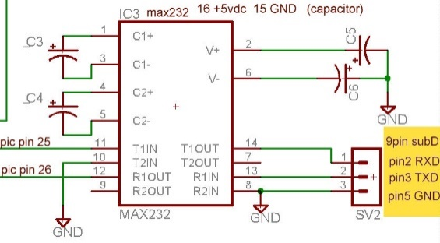The solution would be to put a MAX231 circuit between to convert the level:

When I was making this circuit on a breadboard I started to study, dissemble and measure the NFC board on component level. It became clear that there already was a Chinese replica of the famous MAX232 on the reader itself. After finding the correct pins I could drain the data on the perfect level.

* + 1. Final algorithm

In the end all previous algorithms were very unstable, and then I started thinking outside of the box. I always was looking for something where I could filter the data on. But actually I had to find a way to select the repetitive string and length independent because this can be different by other brands. The idea (**very simplified**) goes as follows:   
e.g. NFC-ID = ‘123456’  
*Incoming data on RX = 123456123456123456123456123456123456123456123456*

The main idea is to compare box A and box B until they are the same. If they aren’t an extra char will be added to the boxes. In the Smart Fridge I start the boxes at a length of 6 to compare to each other because the ID of an NFC-tag will never be shorter than six.  
I can compare the places by putting them in a buffer array of characters.

**IN:** *123456123456123456123456123456123456123456123456***Box[2]:**  *12 34 56 12 34 56 12 34 56 12 34 56 12 34 56 12 34 56 12 34 56 12 34 56*

**Box[3]:**  *123 456 123 456 123 456 123 456 123 456 123 456 123 456 123 456*

**Box[4]:**  *1234 5612 3456 1234 5612 3456 1234 5612 3456 1234 5612 3456*

**Box[5]:**  *12345 61234 56123 45612 34561 23456 12345 61234 56123 456*

**Box[6]:**  *123456 123456 123456 123456 123456 123456 123456 123456* **Box[…] 🡪 Until Box A == Box B**

After converting the idea into code (see 11.2.) this algorithm seemed to work very good and stable. All the ID’s were processed and saved correctly. This really was a break-through.

* 1. Code: Mater module

/*

Master Module of Smart Fridge

-----------------------------

Made by Tom Mampaey

at 'OAMK University of Applied sciences'

Finland - May 2015

The mastermodule controls all the connected slavemodules by I2C-protocol on the two RJ-11 connectors (on right).

It also has a motionsensor port (on left), a temraturesensor and a output port to Wifi (underneath).

The mastermodule is powerd by an 12V 1,5A DC adapter

This code controls all the serial switches on the NFC-readers and converts this data to ID's.

Seven diffrent colors can be dedicated to the RGB-strips of the selected Slave Module.

The converted data will be set in a header before sending over the serial line of the output-port.

*/

// Module adresses:

#define  MOD1  56

#define  MOD2  57

#define  MOD3  58

#define  MOD4  59

#define  MOD5  60

#define  MOD1_R  61

#define  MOD2_R  62

#define  MOD3_R  63

#define  MOD4_R  64

#define  MOD5_R  65

// Colors:

#define Off B00000000

#define Read B00000001

#define Green B00000001

#define Red B00000010

#define Yellow B00000011

#define Blue B00000100

#define BrightBlue B00000101

#define Purple B11111110

#define White B11111111

#include <Wire.h>

// NFC

int incomingByte = 0;

char charBuf[100];

char tempcharBuf[100];

String incomingString = "";

String tempString = "";

boolean ReadNFC = true;

int count = 100;

String productID = "0000";

int ReadDelay = 1000;

int Temprature = 20; // test value

boolean Available = true;

// UserDetection

int duration; // Stores duration of pulse in

int distance; // Stores distance

int sensorpin = 7;

int UserDistance = 30; // in cm

void **setup**()

{

  Wire.begin();

**Serial**.begin(9600);

  ModuleWrite(Off, MOD1);

  ModuleWrite(Off, MOD2);

  ModuleWrite(Off, MOD3);

  ModuleWrite(Off, MOD4);

  ModuleWrite(Off, MOD5);

  ModuleWrite(Off, MOD1_R);

  ModuleWrite(Off, MOD2_R);

  ModuleWrite(Off, MOD3_R);

  ModuleWrite(Off, MOD4_R);

  ModuleWrite(Off, MOD5_R);

}

void **loop**()

{

  //VisualRGBCheck();   
// Visual knight rider of 7 colors for visual check of connection

  // if (DetectUser()) {}   
// Can be interactive, from chaning colors to sending to server (works)

  for (int i = MOD1_R ; i <= MOD3_R ; i++)// Read all the readers.

  {

    SetMod(i);                            // Select NFC-reader

    readID();

    if (productID != "0000")

    {

      ModuleWrite(Green, i - 5);          // Product detected

      Available = true;

    }

    else

    {

      ModuleWrite(Red, i - 5);            // No product

      Available = false;

    }

    SendToWifi(productID, i, Available, Temprature);

    productID = "0000";

    delay(ReadDelay);

  }

}

// Sends assigned data (color or state of serial switch) to specific Module.

**void ModuleWrite(byte txData, int Module_Address)**

{

  Wire.beginTransmission(Module_Address);

  Wire.write(txData);

  Wire.endTransmission();

}

// Reads the data and translates it to an ID

**void readID()**

{

  // ----- NFC-Tag Detection -----

  int LengthCharArr = sizeof(charBuf);

  for (int i = 0; i <= LengthCharArr; i++)   
 // Put incomingbytes in a string of 100 chars

  {

    if (**Serial**.available() > 0) {

      incomingByte = **Serial**.read();

      tempString = String(incomingByte);

      incomingString += tempString;

    }

  }

  incomingString.toCharArray(tempcharBuf, LengthCharArr);    
 // Put incomingString (size 100) in char array (100)

  incomingString = "";

  boolean StartShifting = false;

  int index = 0;

  for (int i = 0; i <= LengthCharArr; i++)

  {

    if (tempcharBuf[i] == '4' && tempcharBuf[i + 1] == '8' && tempcharBuf[i   
 + 2] == '5' && tempcharBuf[i + 3] == '2' && (i + 3) < LengthCharArr)   
 // Shifting array to brand, can be removed to read other tags too

    {

      StartShifting = true;

    }

    if (StartShifting)

    {

      charBuf[index] = tempcharBuf[i];

      index++;

    }

  }

  for (int i = 6; i <= LengthCharArr; i++)   
 // Divide char array in 'boxes' (Starting at 6 because ID never shorter)

  {

    String boxA = "";

    String boxB = "";

    // Box A

    for (int j = 0; j < i; j++)   
// Make first box bigger every round by adding first chars starting from char 0 -> 6

    {

      boxA += charBuf[j];               
 // Add the char at location J (Start: 0 -> 6 and increments each round)

    }

    // Box B

    for (int j = 0; j < i; j++)   
 // Make second box bigger every round by adding the chars starting from char 6 -> 12

    {

      if (j + i < LengthCharArr)   
 // As long as the locations are smaller than the buffer size

      {

        boxB += charBuf[j + i];        
// Add the char at location i + j (starting after chars from box A) 6 -> 12

      }

    }

    // Comparing the boxes

    if (boxA == boxB && boxA != "")

    {

      productID = boxA;    // Final productID

      for ( int i = 0; i < LengthCharArr; ++i ) // Clear buffers of chars

      {

        charBuf[i] = (char)0;

        tempcharBuf[i] = (char)0;

      }

    }

  }

}

// Puts variables in headers on serial line to send out the output port

**void SendToWifi(String iD, int location, boolean Available, int temprature)**

{

  char charArray[50];

  String tempStr = "XD" + iD + "DA" + (String)location + "AB" + (String)Available + "BT" + (String)temprature + "TX";

  tempStr.toCharArray(charArray, 50);

**Serial**.write(charArray);

}

// Visual knight rider of 7 colors for visual check of connection

**void VisualRGBCheck()**

{

  int timer = 200;

  for (int count = 0; count < 3; count++) {

    ModuleWrite(Green, MOD1 + count);

    delay(timer);

    ModuleWrite(Red, MOD1 + count);

    delay(timer);

    ModuleWrite(Yellow, MOD1 + count);

    delay(timer);

    ModuleWrite(Blue, MOD1 + count);

    delay(timer);

    ModuleWrite(BrightBlue, MOD1 + count);

    delay(timer);

    ModuleWrite(Purple, MOD1 + count);

    delay(timer);

    ModuleWrite(Green, MOD1 + count);

    delay(timer);

  }

  for (int i = 0; i < 3; i++) {

    for (int count = 0; count < 3; count++) {

      ModuleWrite(Off, 56 + count);

    }

    delay(timer);

    for (int count = 0; count < 3; count++) {

      ModuleWrite(White, 56 + count);

    }

    delay(timer);

  }

}

// Detects users in front of fridge, gives countless options to implement

**boolean DetectUser()**

{

  pinMode(sensorpin, OUTPUT);

  digitalWrite(sensorpin, LOW); // Make pin low before sending a short high to trigger ranging

  delayMicroseconds(2);

  digitalWrite(sensorpin, HIGH); // Sends short 10 microsecond high on pin to start ranging

  delayMicroseconds(10);

  digitalWrite(sensorpin, LOW); // Set pin low again before waiting for pulse back in

  pinMode(sensorpin, INPUT);

  duration = pulseIn(sensorpin, HIGH); // Reads echo pulse in from SRF05 in microseconds

  distance = duration / 58;                              // /58 is distance in cm

**Serial**.print("Seesam says: ");

  if ( distance < UserDistance)

  {

**Serial**.println("USER DETECTED IN FRONT OF FRIDGE!");

    return true;

  }

  else

  {

**Serial**.print("Motion detected on ");

**Serial**.println(distance);

    return false;

  }

  delay(500);

}

// Configures modules correctly to make sure only that module is reading!

**void SetMod(int SelectedMod)**

{

  switch (SelectedMod) {

    case 61:

      ModuleWrite(Purple, MOD1);

      ModuleWrite(White, MOD2);

      ModuleWrite(White, MOD3);

      ModuleWrite(Off, MOD1_R);

      ModuleWrite(Read, MOD2_R);

      ModuleWrite(Off, MOD3_R);

      break;

    case MOD2_R:

      ModuleWrite(White, MOD1);

      ModuleWrite(Purple, MOD2);

      ModuleWrite(White, MOD3);

      ModuleWrite(Off, MOD1_R);

      ModuleWrite(Off, MOD2_R);

      ModuleWrite(Read, MOD3_R);

      break;

    case MOD3_R:

      ModuleWrite(White, MOD1);

      ModuleWrite(White, MOD2);

      ModuleWrite(Purple, MOD3);

      ModuleWrite(Read, MOD1_R);

      ModuleWrite(Off, MOD2_R);

      ModuleWrite(Off, MOD3_R);

      break;

  }

}

* 1. Compose header to send

When all the required data is collected by the master it is ready to send to the output port.   
In order to make sure that the data is received correctly by the Wifi salve I insert the data in a sort of a header.

I do this in the following function with declared parameters. Respectively: The NFC-ID of the product, the location of the product in the fridge, the availability of the product and the in- or outside the refrigerator.

SendToWifi(String iD, int location, boolean Available, int temprature)

The headers will be send continuously to the output port so that a change in the header is immediately is detected. I send the headers of the different slave modules in succession to the Wi-Fi slave, with following alignment:

**XD4875242556256255935332DA56AB1BT3TX***XD4875242556256255948567DA57AB0BT2TX…*

Every header is mutually parted by two **X**’s. Between these two the content of the header is constructed. Between the:   
**D** = NFC-ID of product  
**A** = The address/location of the product in the refrigerator   
**B** = The availability of the product (if it is still there)   
**T** = The temperature of the fridge

* 1. Serial level conversion

|  |  |  |
| --- | --- | --- |
|  | Arduino MEGA | Arduino DUE |
| System voltage | 5V | 3.3V |
| Clock speed | 16MHz | 84MHz |
| Programming interface | USB (ATMega16US) | USB Native |

Because the master module has to deal with heavy calculations /algorithm and has to be able to control up to 127 devices on the serial I2C protocol with an acceptable delay, the use of an Arduino DUE instead of the MEGA recommended.

To convert the serial level of the data from 5V level to 3V3 I constructed following circuit.   
These are used on the serial RX-lines towards the DUE and coming from the Wi-Fi slave. (D1;D2)

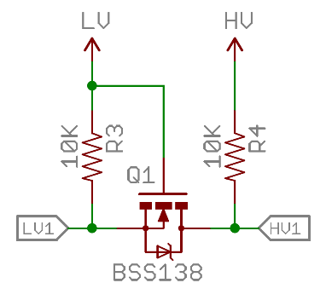

* 1. Schematic
* See next page (full page view)

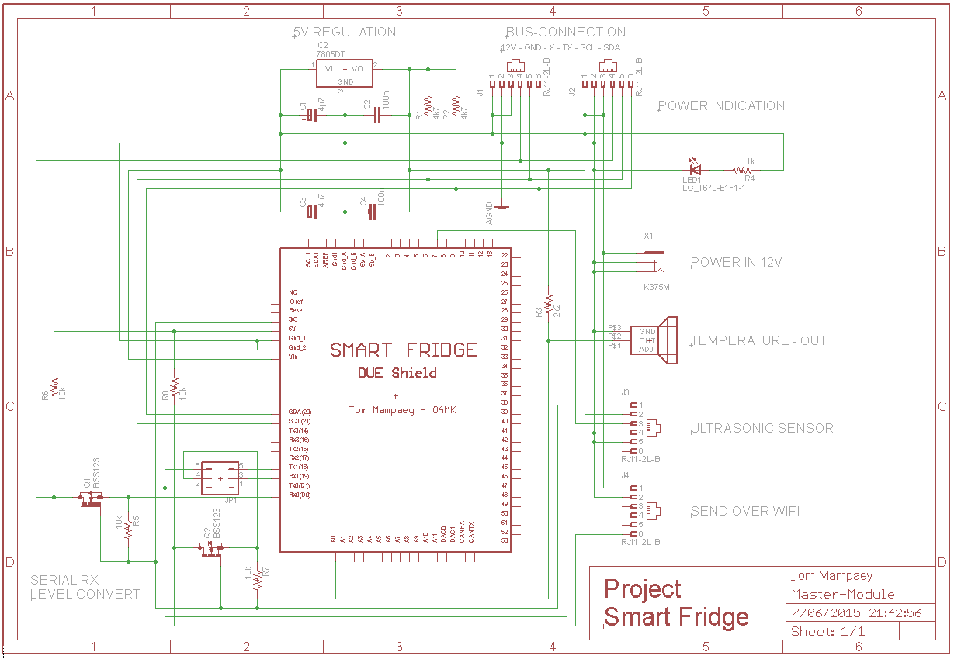

* 1. PCB design

Like the slave modules I gave a lot of attention to placing the components and also added enough labels at every in- or output. In this way it’s very clear what to connect where so no mistakes are made. Up to 127 devices (slaves) can be connected to the two RJ-11 connectors on the right.

* + 1. Layers

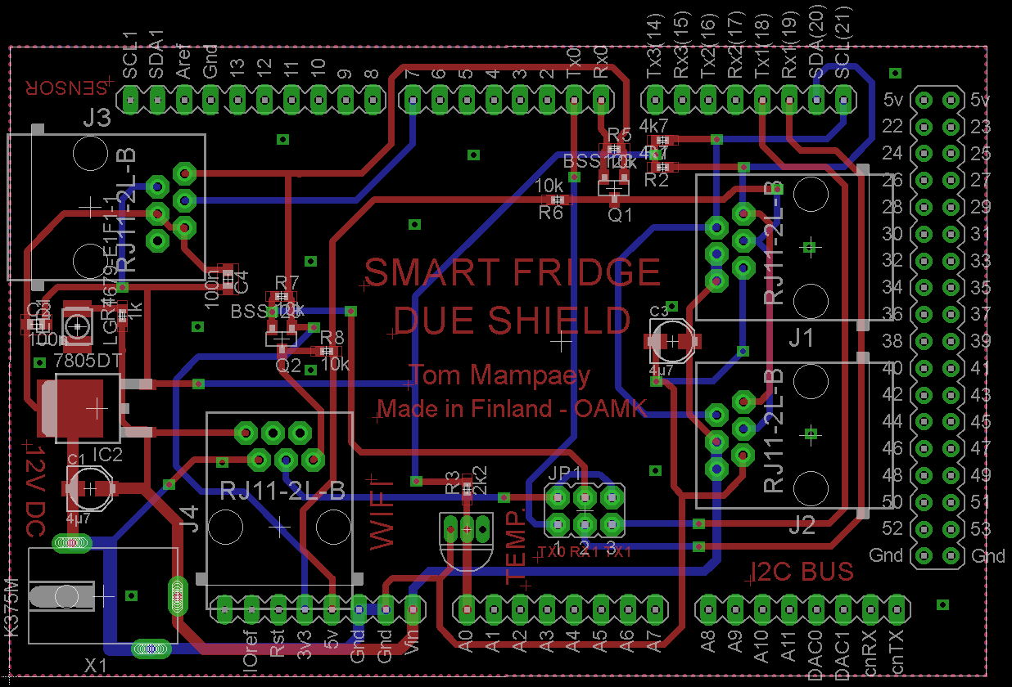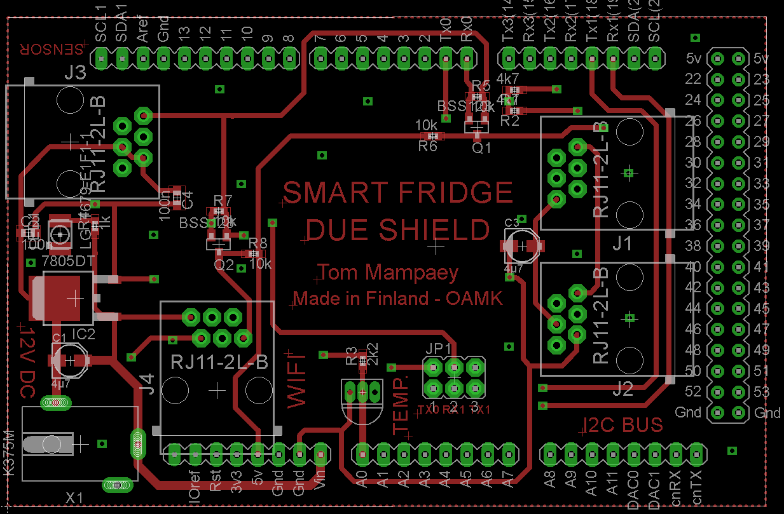

Main (/top) layer Added second (/bottom) layer

* + 1. 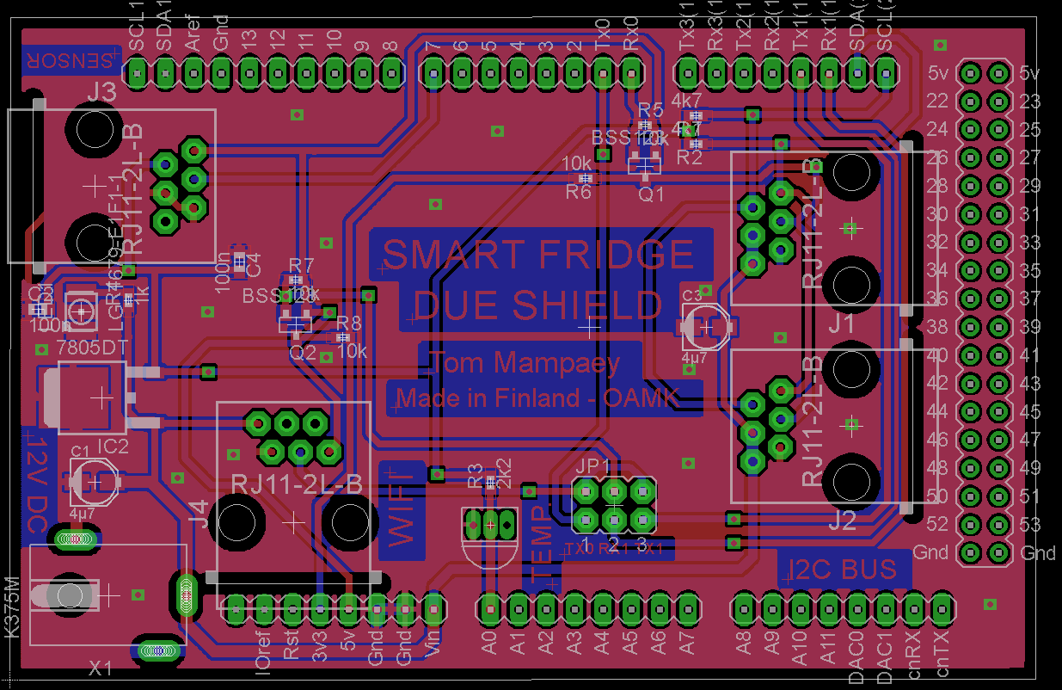Final PCB including ground plane

Wi-Fi output port

Custom temperature sensor

SDL – SCL   
Pull up’s   
  
Serial level conversion

I2C connectors

Serial line  
jumper Wi-Fi

Ultrasonic detection  
port  
  
Power indication

Voltage regulator  
Peak filters (cap.)  
  
Voltage supply  
 9V DC – 1.5A

1. Extension: Wi-Fi Module

The original idea was to connect the master module to a computer through an USB-connection and send the data to the server with an external application. The more I was working to that idea the more devious I thought it was, without even mentioning the overkill it would be.   
So I did everything in the planning to make this possible in a performant and enhanced way.   
Because the most ‘internet of things’ (IoT) nowadays are mostly connected through Wi-Fi I thought replacing the computer by a Wi-Fi module that would send the data straight to the server. I also did research and testing to use an Ethernet shield but the Wi-Fi technology sued me more.   
It soon became clear that it was a good idea to replace the computer by a Wi-Fi slave.

The modification/improvement to the original High-level schematic (see 7.):   
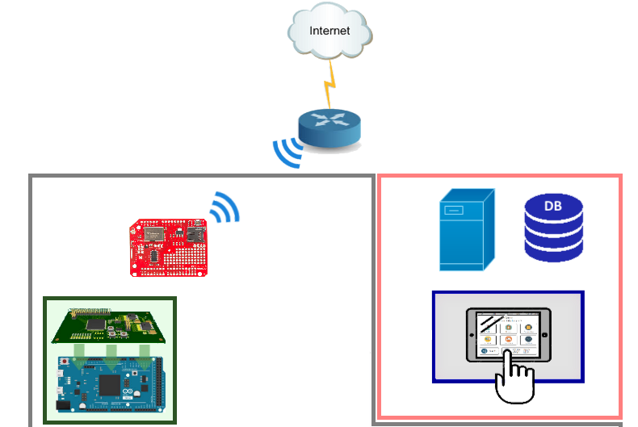

Wi-Fi Slave

Master module

**Embedded side**

**UI/Server side**

Server Database

Router

* 1. CC3000 module

The module I chose for this extension is the CC3000 from Texas Instruments. The CC3000 utilizes the SPI (16MHz) interface instead of the more standard UART communication method. In this way it is possible to control the flow of the data. The module uses the IEEE 802.11 b/g standard and can be configured in the different security modes WEP, WPA/WPA2 (AES and TKIP - Personal).  
The CC3000 has an onboard Wimax antenna and an optional connection for an external one.

I use an Arduino Mega to control this module (DUE not supported). The Arduino will receive the headers coming from the master module and convert them into a JSON string. I programmed the module that it will automatically will make connection with the ‘Smart Kitchen’ router.   
I had to customize the shield due the project.

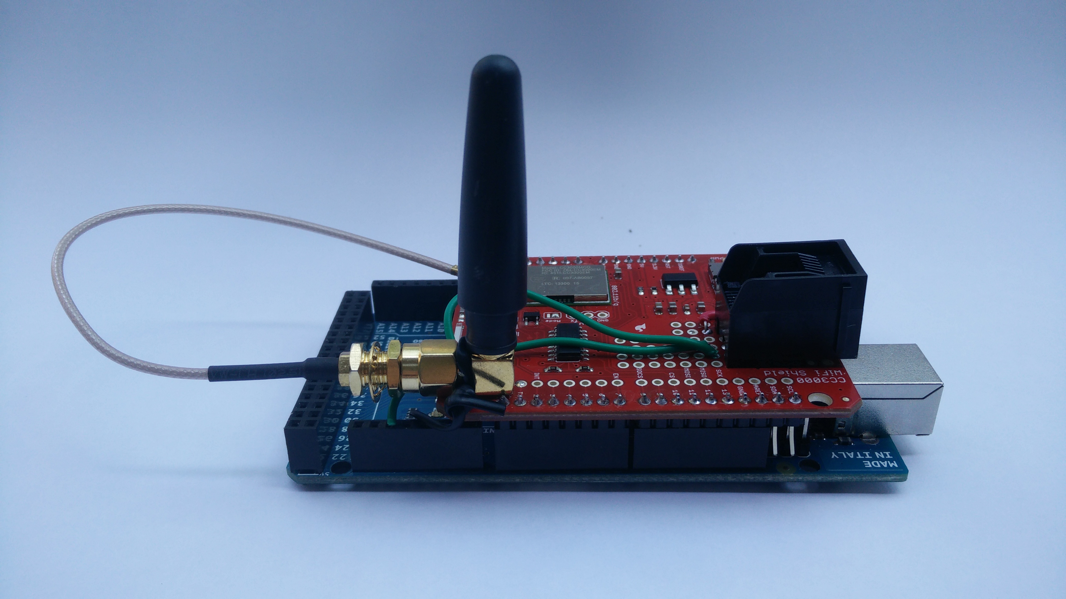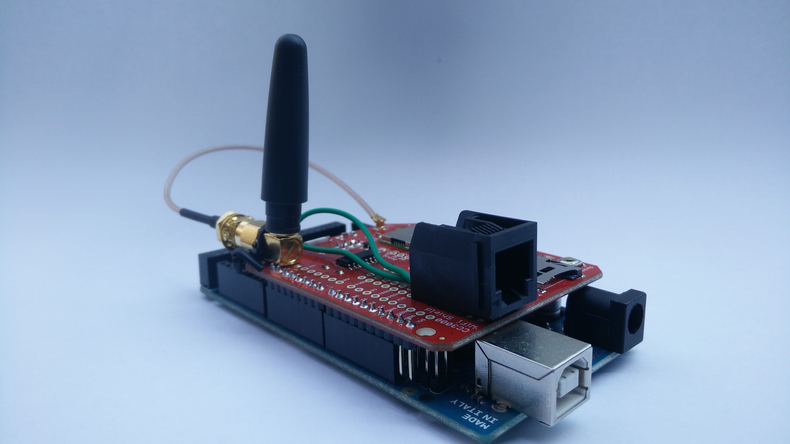

* 1. Code

/*

SEND PRODUCT INFORMATION TO SERVER

----------------------------------

Made by Tom Mampaey

at 'OAMK University of Applied sciences'

Finland - May 2015

Gets product information from MASTER-board SmartFridge on Serial 1 line.

Sends JSON data (PUT) to the server using WiFi

Code based on the GET-request example of WebClient SFE

*/

#include <SPI.h>

#include <SFE_CC3000.h>

#include <SFE_CC3000_Client.h>

// Pins

#define CC3000_INT 2   // Needs to be an interrupt pin

#define CC3000_EN  7   // Digital pin

#define CC3000_CS  10  // cs pin (best 10 on if you use uno)

// Connection info data lengths

#define IP_ADDR_LEN 4   // Length of IP address in bytes

// Internet settings (constants)

char ap_ssid[] = "SmartKitchen"; // SSID of network

char ap_password[] = "12345678"; // Password of network

unsigned int ap_security = WLAN_SEC_WPA2; // Security of network

unsigned int timeout = 30000; // Milliseconds

char server[] = "api.verhofstadt.eu"; // Remote host site

String data = " ";

int led = 50;

// Reading from Master Module

char incommingByte;

String incommingString;

char charArray[80];

boolean initComplete = false;

boolean dataReceived = false;

String NFC_ID = "";

String Address = "";

String Availability = "";

String Temprature = "";  
String inData = "";

// Global Variables

SFE_CC3000 wifi = SFE_CC3000(CC3000_INT, CC3000_EN, CC3000_CS);

SFE_CC3000_Client client = SFE_CC3000_Client(wifi);

void **setup**() {

**Serial**.begin(9600);

**Serial1**.begin(9600);

  pinMode(led, OUTPUT);

  digitalWrite(led, LOW);

  ConnectionInfo connection_info;

  int i;

  // Initialize Serial port

**Serial**.println("----------------------------------");

**Serial**.println("SmartFridge CC3000 - PUT to Server");

**Serial**.println("----------------------------------");

  // Initialize CC3000 (configure SPI communications)

  if ( wifi.init() ) {

**Serial**.println("CC3000 initialization complete");

  } else {

**Serial**.println("Error: CC3000 initialization incomplete");

  }

  // Connect using DHCP

**Serial**.print("Connecting to SSID: ");

**Serial**.println(ap_ssid);

  if (!wifi.connect(ap_ssid, ap_security, ap_password, timeout)) {

**Serial**.println("Error: Could not connect to AP");

  }

  // Connection details and print IP address

  if ( !wifi.getConnectionInfo(connection_info) ) {

**Serial**.println("Error: Could not obtain connection details");

  } else {

**Serial**.print("IP Address: ");

    for (i = 0; i < IP_ADDR_LEN; i++) {

**Serial**.print(connection_info.ip_address[i]);

      if ( i < IP_ADDR_LEN - 1 ) {

**Serial**.print(".");

      }

    }

**Serial**.println();

  }

  // Make TCP connection to remote host

**Serial**.print("Performing HTTP PUT to: ");

**Serial**.println(server);

  client.connect(server, 80);

  if (client.connected()) { //initiate connection

**Serial**.print("Connected to: ");

    digitalWrite(led, HIGH);

  }

  else {

**Serial**.print("Failed to connect with: ");

    digitalWrite(led, LOW);

  }

**Serial**.println(server);

  /*

    // Make a HTTP GET request (works!)

    client.println("GET /service/exercises HTTP/1.1");

    client.print("Host: ");

    client.println(server);

    client.println("Connection: close");

    client.println();

    Serial.println();

  */

}

void **loop**()

{

  inData = "";

  if (**Serial1**.available())

  {

    delay(100); //allows all serial sent to be received together

    while (**Serial1**.available())

    {

      char recieved = **Serial1**.read();

      inData += recieved;

    }

  }

  if (!inData.equals(""))

  {

    inData.toCharArray(charArray, 100);

    //Constructing Json to PUT

    String ID = GetId();

    String Address = GetAddress();

    String Available = GetAvailability();

    String temprature = GetTemprature();

    data = "{\"IdNFC\":\"" + ID + "\",\"Address\":\"" + Address + "\",\"Available\":\"" + Available + "\",\"TemperatureFridge\":\"" + temprature + "\"}";

    SendToServer(data);

  }

}

**String GetContentByFilterOn(char filter)**

{

  bool readd = false;

  bool stopread = false;

  String content = "";

  for (int i = 0; i < sizeof(charArray); i++)

  {

    if (stopread)

    {

      return content; //return string with filtered data

    }

    if (readd)

    {

      if (charArray[i] != filter)

      {

        content.concat(charArray[i]);//connect chars in buff to form string

      }

    }

    if (charArray[i] == filter) // Keep reading until filter char detected

    {

      readd = !readd;

      if (readd == false)

      {

        stopread = true;

      }

    }

  }

}

**void SendToServer(String data)**

{

  if (client.connect(server, 80))

  {

    if (client.connected())

    {

      client.println("PUT /service/Hardware/Product HTTP/1.1");

      delay(5); // added short delays to avoid overload

      client.print("Host: ");

      client.println(server);

      delay(5);

      client.print("Content-Length: ");

      client.println(data.length()); // without quotes

      delay(5);

      client.println("Cache-Control: no-cache");

      delay(5);

      //client.println("Connection: keep-alive");

      //client.println("Content-Type: text/plain; charset=utf-8");

      //client.println("Content-Transfer-Encoding: base64");

      //client.println("Accept-Encoding: gzip, deflate, sdch");

      client.println("Content-Type: application/json");

      delay(5);

      client.println();

      delay(5);

      client.println(data);

**Serial**.println(data);

            for (int i = 0; i < 50; i++){

          char c = client.read();

**Serial**.print(c);

      }

      client.stop();

    }

  }

  else

  {

**Serial**.println("Time-out: Could not make TCP connection");

    client.connect(server, 80);

  }

}

**String GetHeader()**

{

  return GetContentByFilterOn('X'); // Filter NFC-ID by data between 'D'

}

**String GetId()**

{

  return GetContentByFilterOn('D'); // Filter NFC-ID by data between 'D'

}

**String GetAddress()**

{

  return GetContentByFilterOn('A'); // Filter Address by data between 'A'

}

**String GetAvailability()**

{

  return GetContentByFilterOn('B'); // Filer Av. by data between 'B'

}

**String GetTemprature()**

{

  return GetContentByFilterOn('T'); // Filter Temp. by data between 'T'

}

* + 1. GetContentByFilterOn

One of the smart functions I made in this code is the GetContentByFilterOn method.

**String GetContentByFilterOn(char filter)**

This function will read and decode the data of the headers send by the master module.   
The beautiful thing about this function is that I can use it to filter on every single different char.   
  
If (header) data is detected on the Serial 1 line (pin 18: TX, pin 19: RX), a buffer will be filed with these values. This method will then be used to filter out the data on the specific char.

E.g. XD4875242556256255935332DA56AB1BT3TX  
🡪 GetContentByFilterOn('D');   
🡪 Result: 4875242556256255935332

To make the code as readable as possible I added extra methods for every char.   
This makes it very easy to expand extra values into the header. (see last 5 methods)

* + 1. SendToServer

When all the data is successful declared out of the header I transform the values into a JSON string.  
The connection with the server is already made by during the setup of the code.

data = "{\"IdNFC\":\"" + ID + "\",\"Address\":\"" + Address + "\",\"Available\":\"" + Available + "\",\"TemperatureFridge\":\"" + temprature + "\"}";

If the JSON string is ready: e.g.   
{"IdNFC":"4875242556256255935332","Address":"56","Available":"1","TemperatureFridge":"3"}  
  
I request to do a PUT on *(http://api.verhofstadt.eu)/service/Hardware/Product HTTP/1.1*This is where the databank is located on the net (Host: api.verhofstadt.eu).

To make I error proof it’s important to specify the content type (application/json), the cache control (no-cache) and the specific length of the JSON string.

Extra parameters can be added in the header here but isn’t necessary for this application.

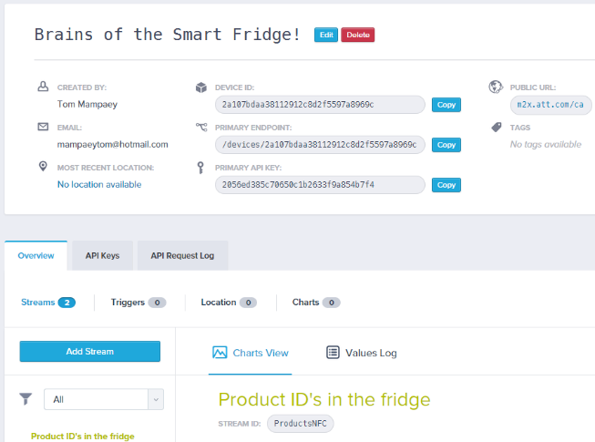Note: For testing purposes I configured a small M2X-databank before testing it on the real one.   
 (<https://m2x.att.com> AT&T IoT Services: easy to implement RESTful API’s and native SDK’s)

* 1. Response of server and ping

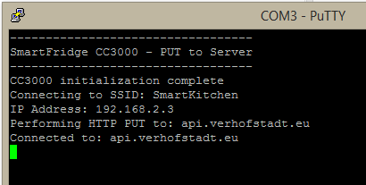To make it myself easier and to deliver a transparent system I print everything that happens to the serial monitor. So when you connect your USB of your computer to the Wi-Fi slave module you monitor every step and get error messages.

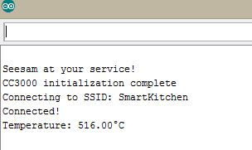

* + 1. Ping to server

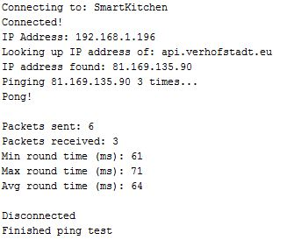I installed, configured and completely tested all the connections my slave board made the first ping to the server.

When this finally worked I started to test a PUT-request to the server via ‘Postman - REST Client’ with JSON string that the Wi-Fi slave generated. If I receive a HTTP status code of 200 as response of the server the PUT has been successfully. Of course I had this problems to:   
*HTTPS response 409 = conflict with the current state of the resource*  
  
Most common HTTPS status codes:

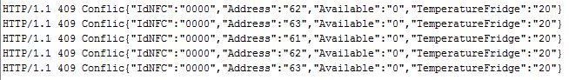

|  |  |  |  |  |
| --- | --- | --- | --- | --- |
| 200 | 400 | 404 | 500 | 550 |
| OK / Success | Bad request | Not found | Server error | [Permission denied](http://www.smartlabsoftware.com/ref/http-status-codes.htm#code-550) |

1. Custom Printed Circuit Boards

For prototyping a project one of the main subjects is to design a performant printed circuit board for the application. This is a part that really can’t be underestimated. For every little component you have to check the datasheets, sepcs, operating temperatures (fridge), testing on a breadboard, placing them strategic and solder them with a microscope to make sure the connection is secure.

* 1. Test boards

It’s obvious that you can’t make the perfect functional print of the first time. You have to make different versions in order to detect and discover all the unforeseen errors to optimize the board to the fullest. I did this for every board I made (inc. breadboard and simulation)

* + 1. Problem solving

As stated previously the main reason to optimize the board to the maximum and eliminate even the smallest flaws. This can go from adding ‘pull up/down’ resistors to complete filters and rewiring the connections. But also practical things, like make some pads a little bit bigger to enable to solder it solid.

A good example of the reason why I’m happy that I made those test boards is a gigantic disturbance that appeared on the LED-drivers when a tag is detected.

For driving and controlling the different colors of the RGB LEDS I use Field Effect Transistors (bka FET’s). One of their properties is that they are very sensitive to static electricity!

If you look close to the construction of the Slave boards you can see that these FET’s are very close to the NFC reader part. This reader has an of course an antenna to detect the NFC tags in his range. With the antenna so close to the sensitive FET’s lots of interference by radiation occurred. When I found that problem I could eliminate it with an extra ground and a diffusedly ground plane. This were faults I didn't think about in the first place. That's why it's good to make some test boards first!

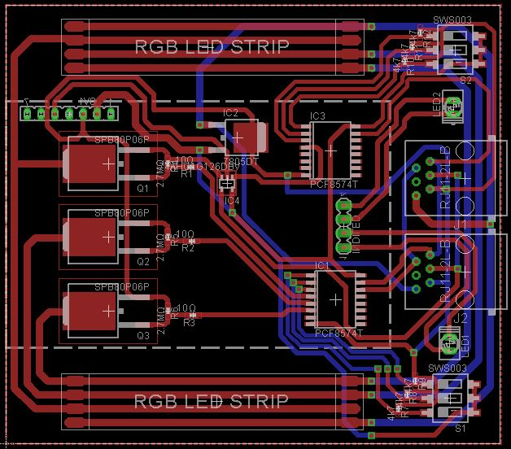

*Test board version 1.0 Final PCB design*

* 1. Surface Mounted Device (SMD)

I was very thrilled when I saw I had the option to work with SMD’s for this project. I never had done this before but I have been interested in this technology for a long time. OAMK was very intent in this technology and provided professional facilities.

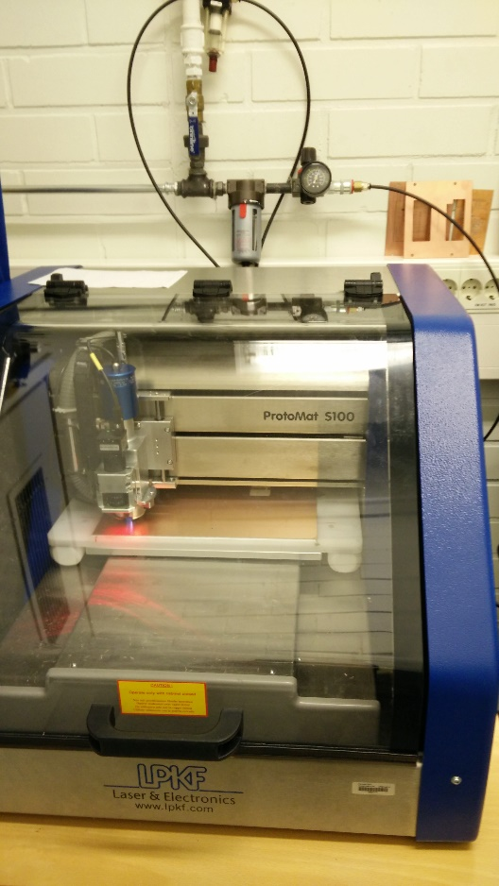SMD is the group of components that are the smallest brazed in the world. These components are soldered on top of a copper plate. The connections between them are milt by a very accurate machine. Solder components smaller than 2mm isn’t extraordinary.

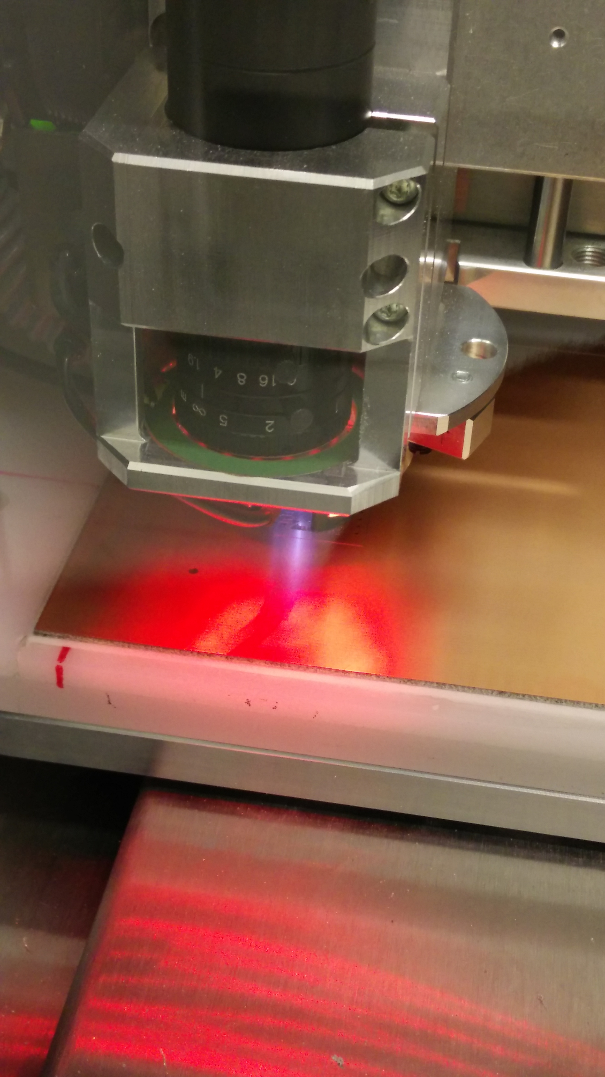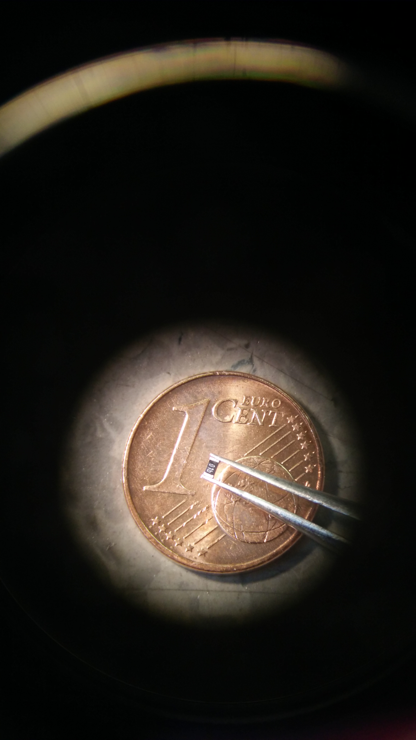

Because I never had any experience with SMD designing, soldering or doing data research about it, it was good to start small. I designed a custom component in Eagle 6.5.0 for the SC16IS750 which is a Single UART with I2C-bus/SPI interface that I was planning to use in the beginning.

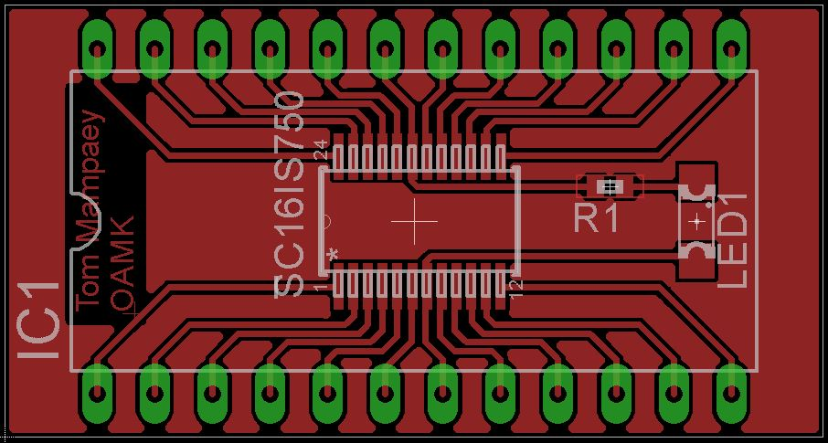When my design was checked by the experienced prototype manager I was ready to mill my first little SMD board ever. After spending almost half a day trying to solder it my first SMD was ready.

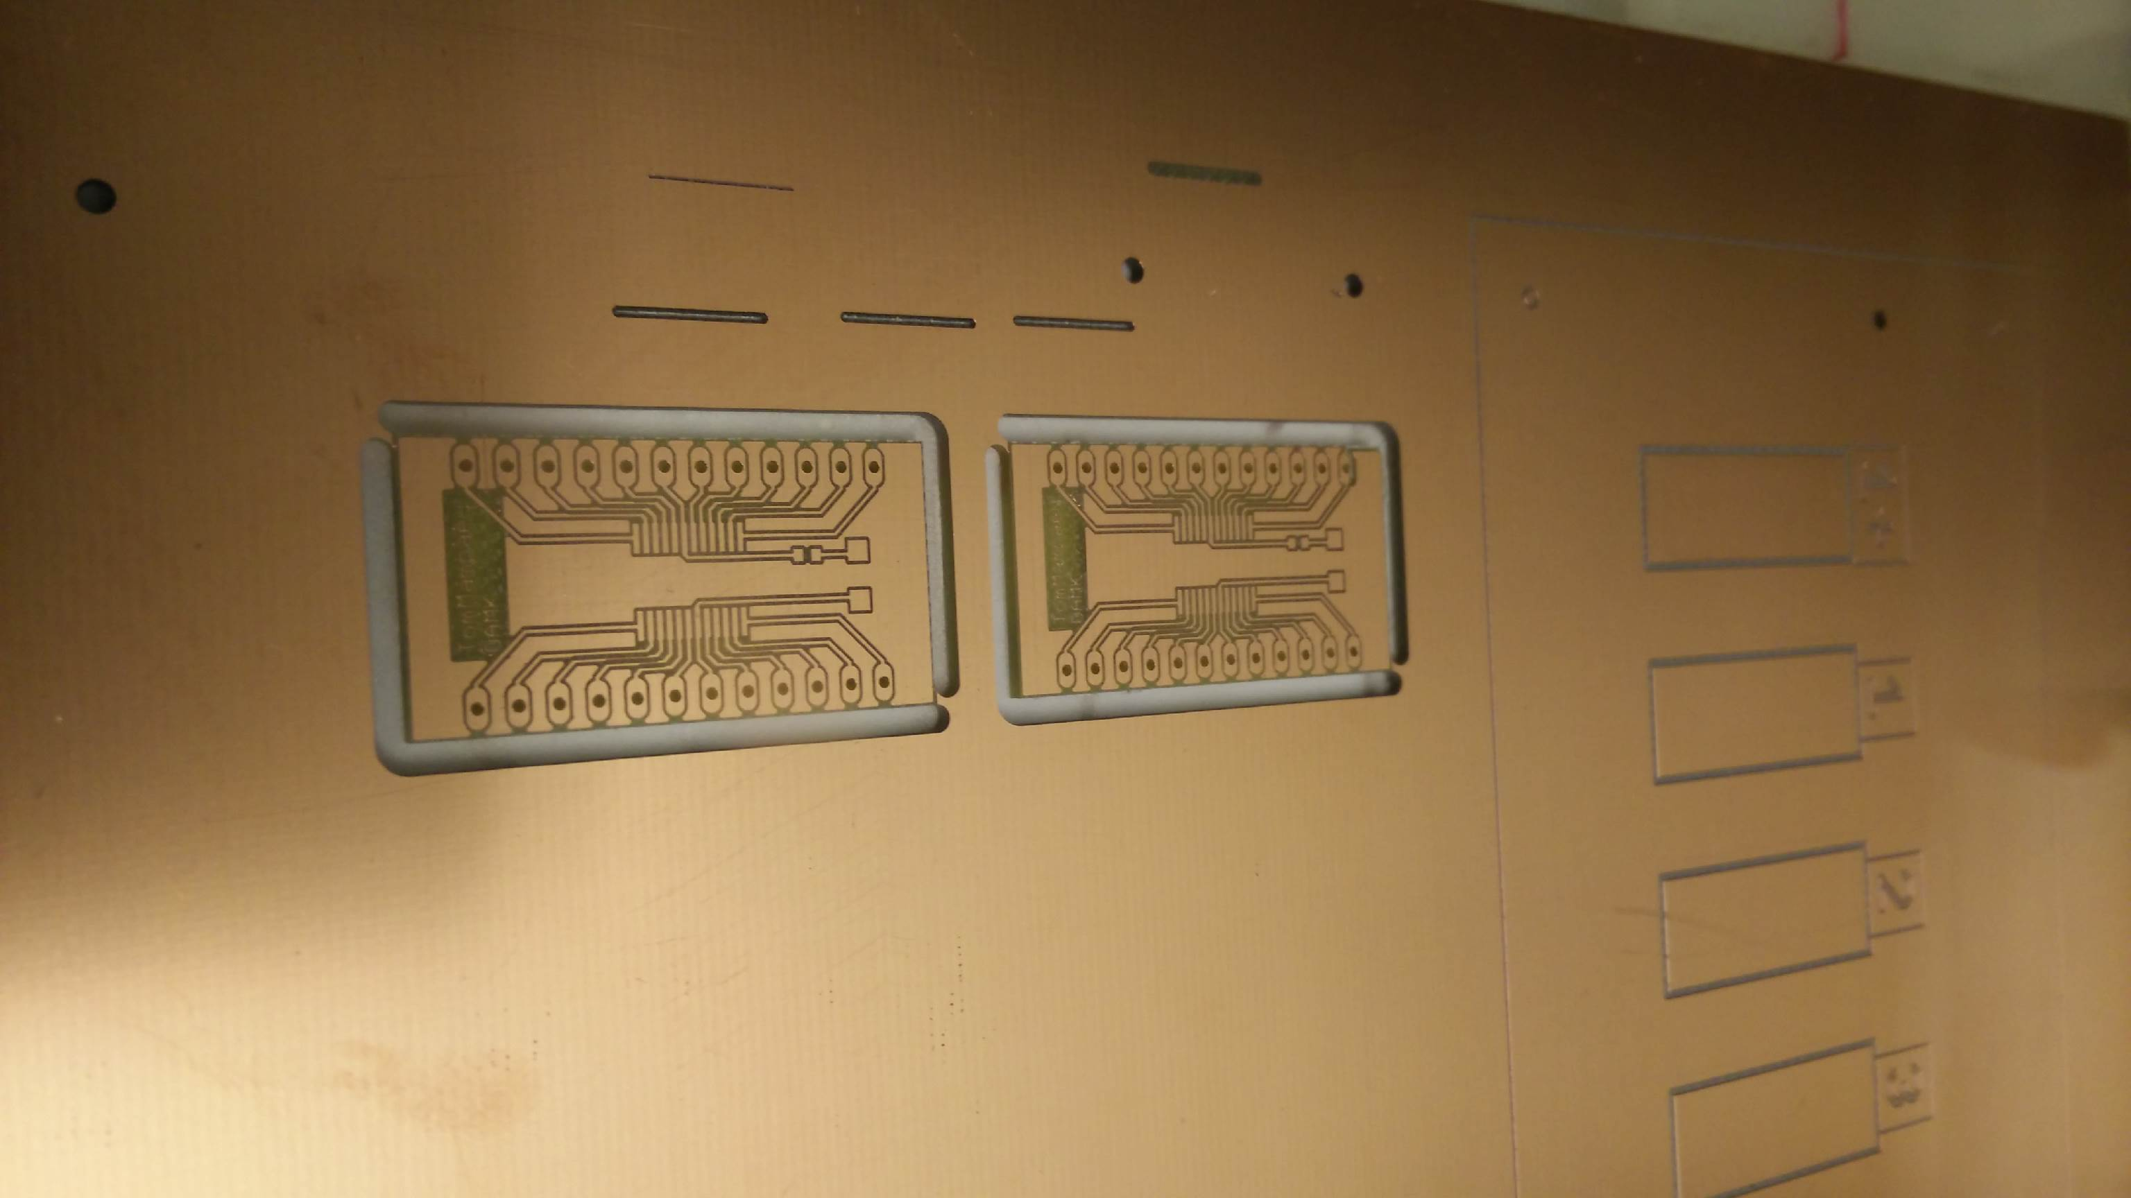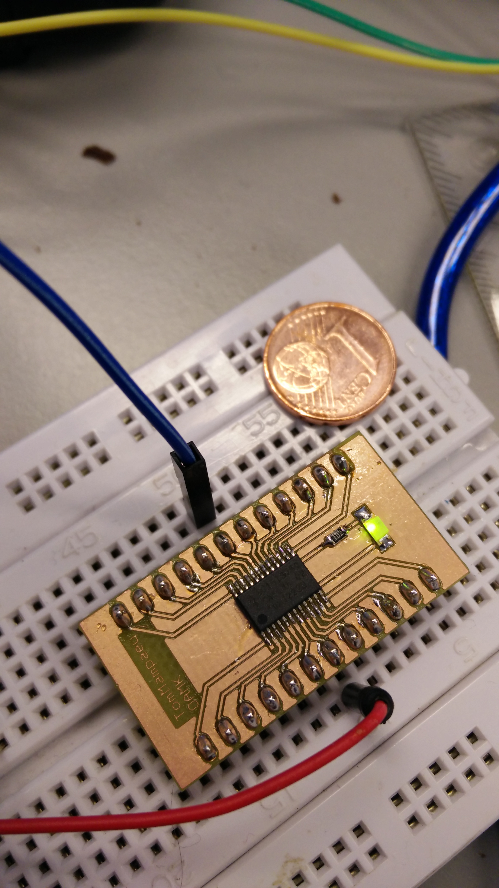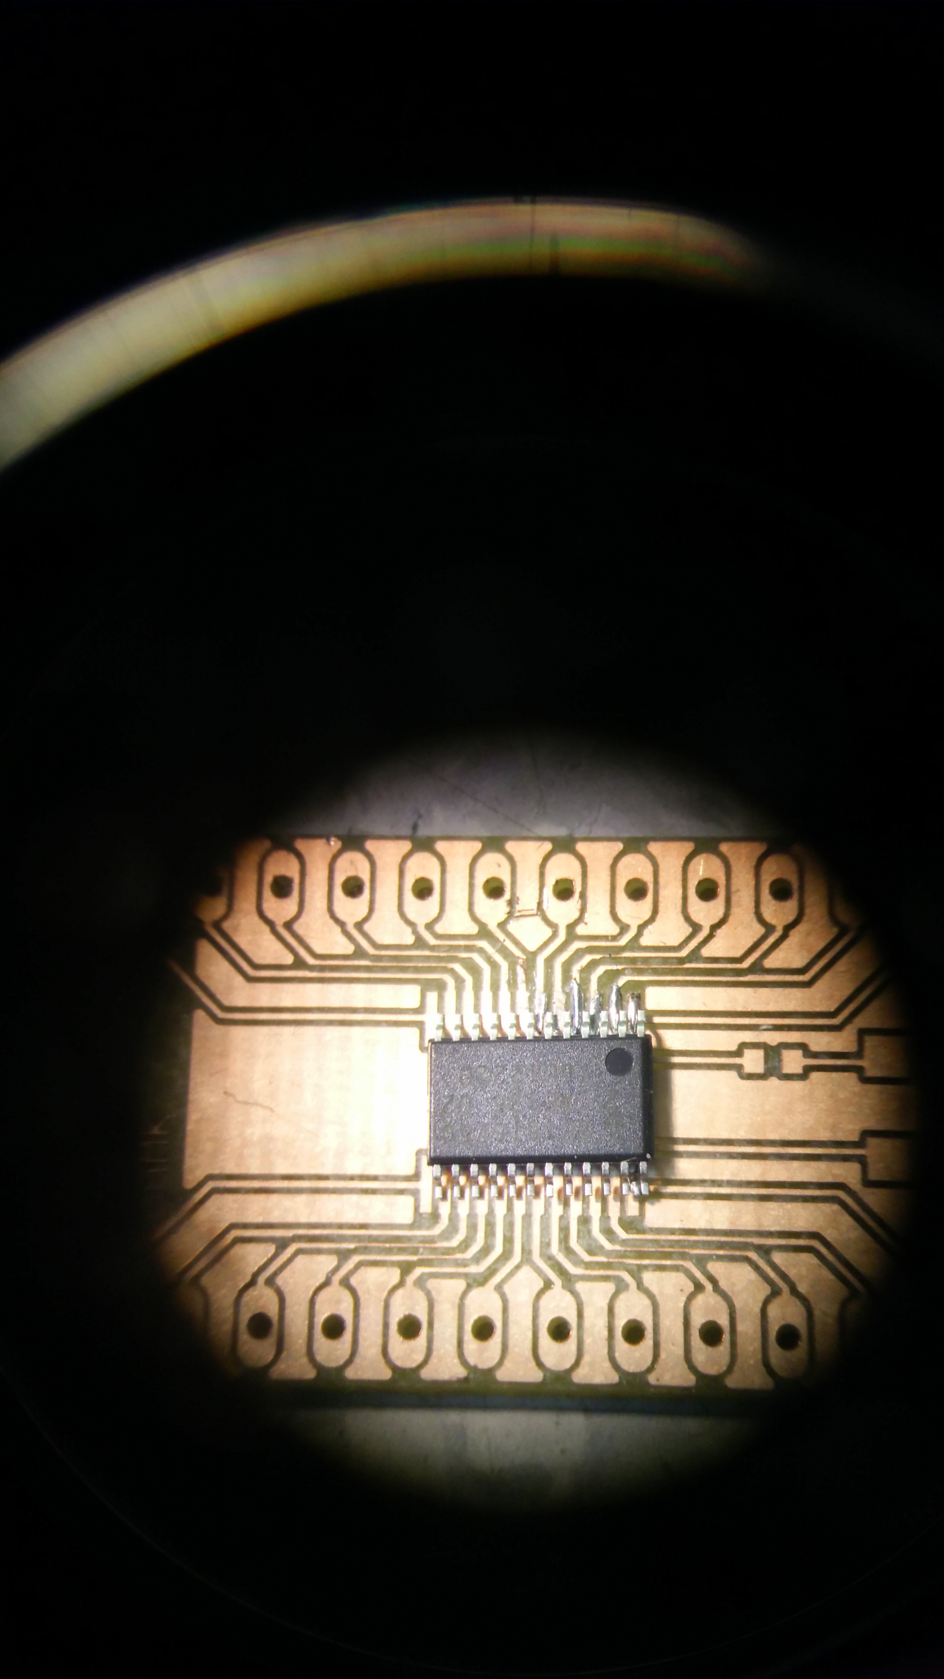

* 1. Production of final PCB
     1. Design and conversion

When the design has been triple checked the required files are generated for the milling machine (.lmd, .drill, .mill , .lpkf,…). The commands (in universal G-code) send from the computer to the milling machine are based on these files. For the example I will take the master and slave board.  
  
*Software that controls milling machine. Top layer - Master board. Milling camera at right-hand corner*

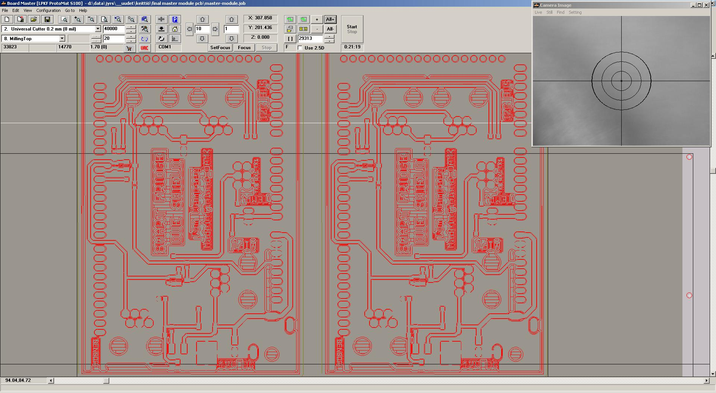

* + 1. Drilling and through hole plating

The first thing that’s next, after the calibration and setting the correct tools, is to drill the holes very accurate into the copper plate. When the drilling is done the copper plate goes into a series of chemical cleaning substances. Three different kinds of cleaning baths for each approximately between 2 and 10 minutes.

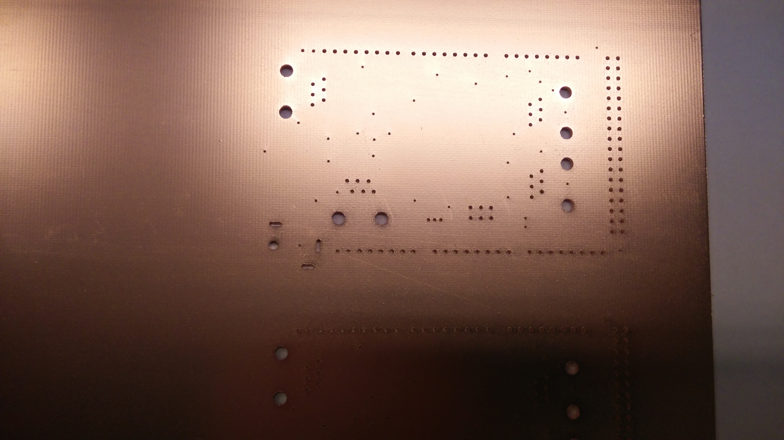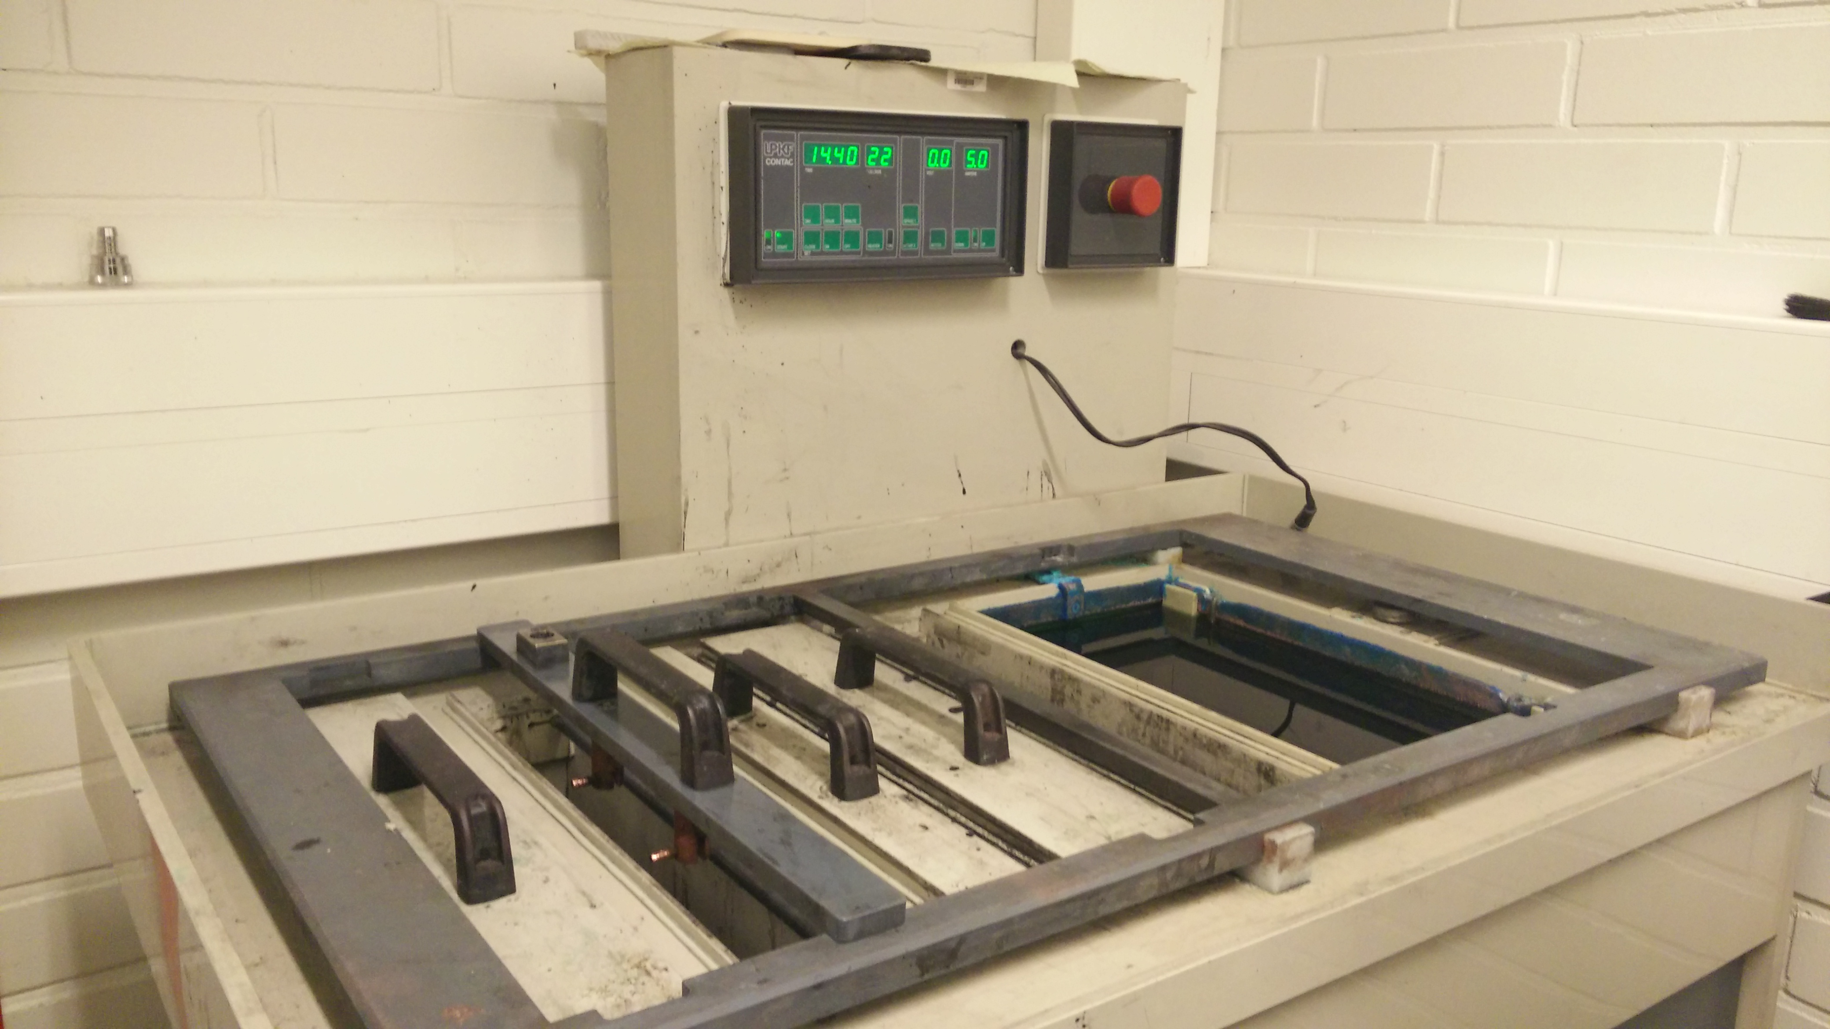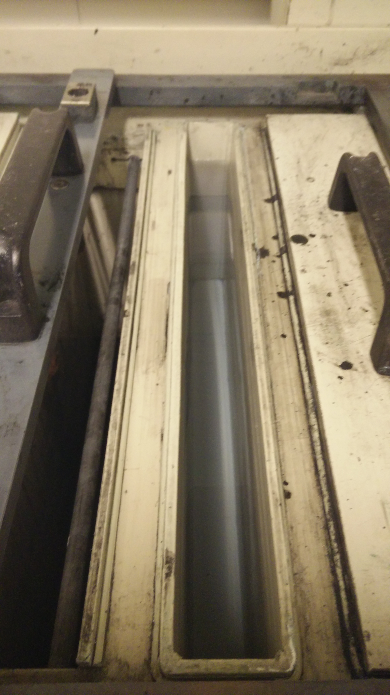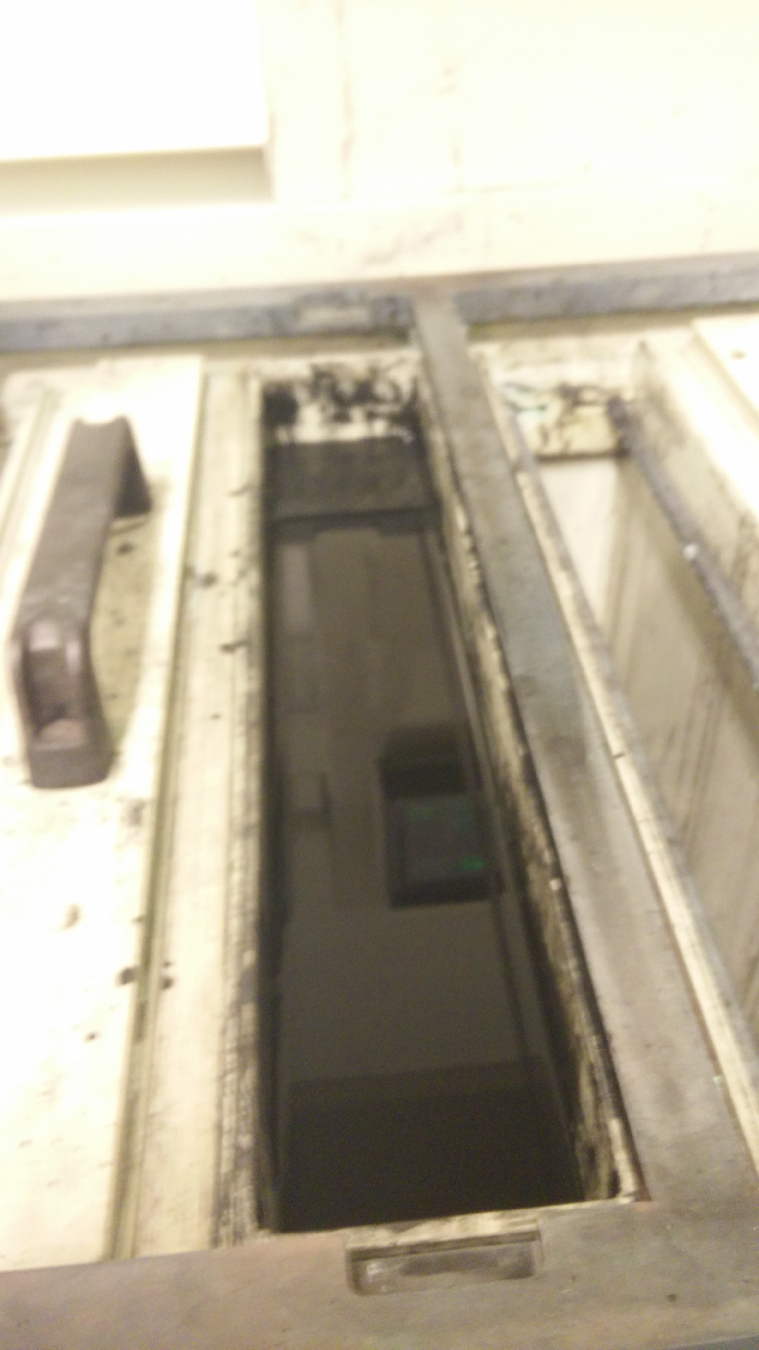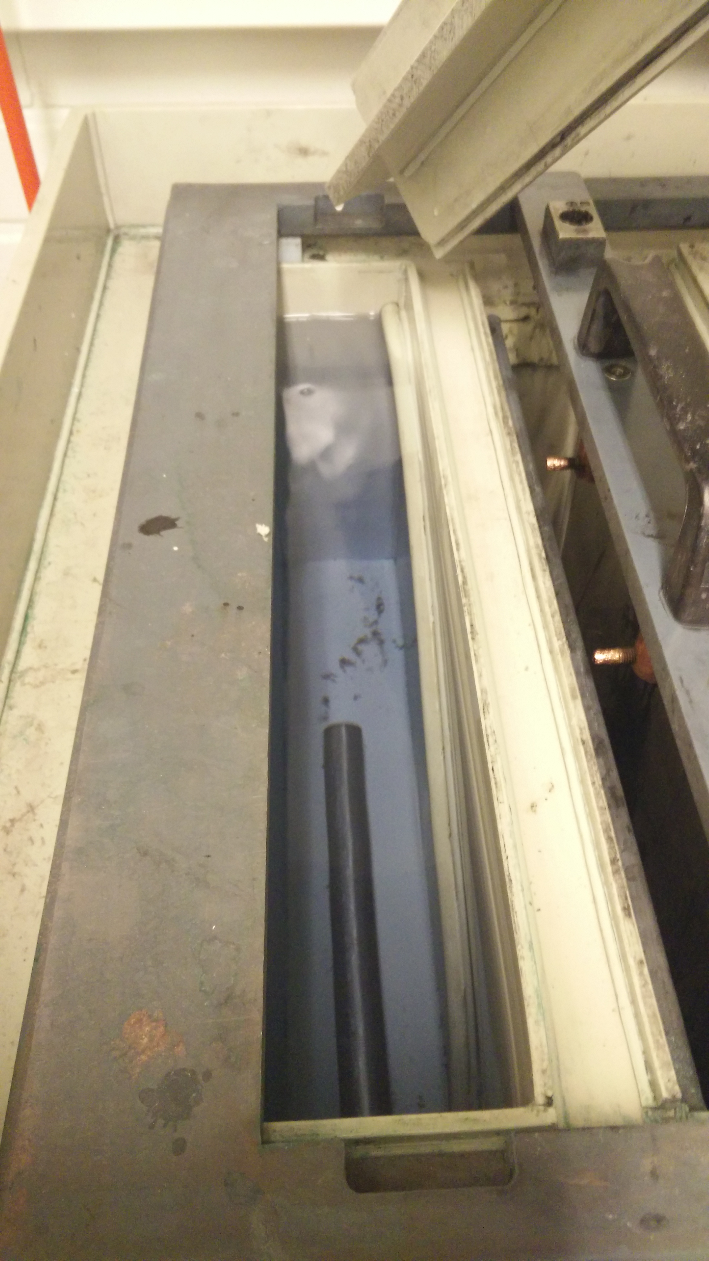

If the copper is clean it’s ready for through hole plating. The board will be immersed into chemicals, connected to a power source. The positive and ground between the bath and the board will have the chemical effect of attracting and saturate copper particles at the inside of the holes.

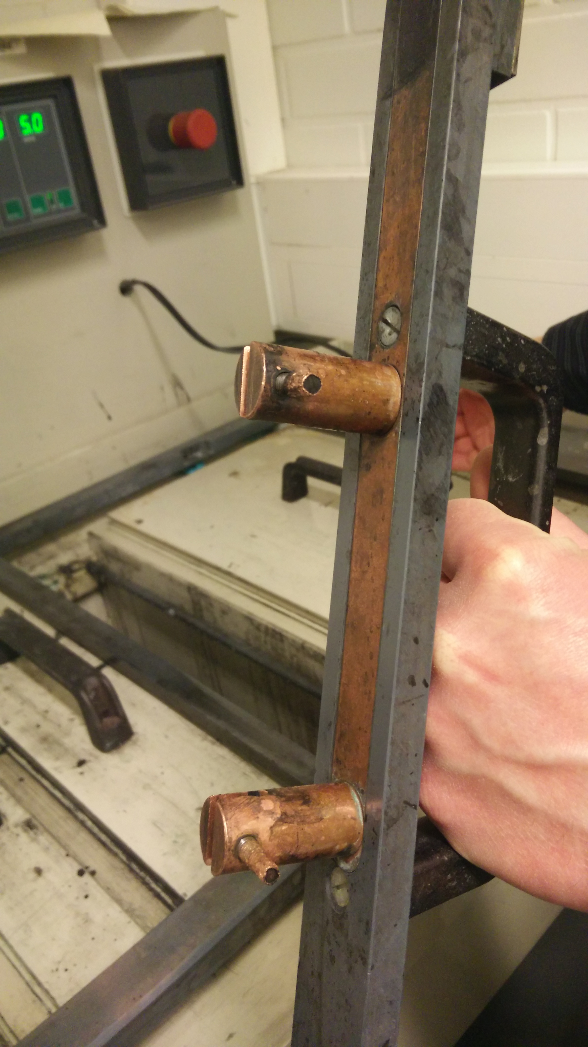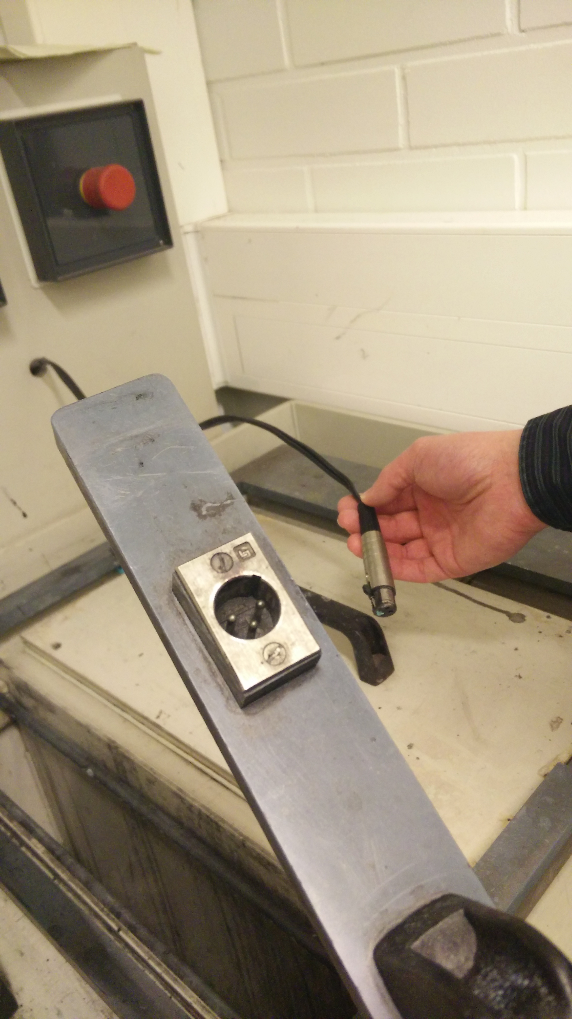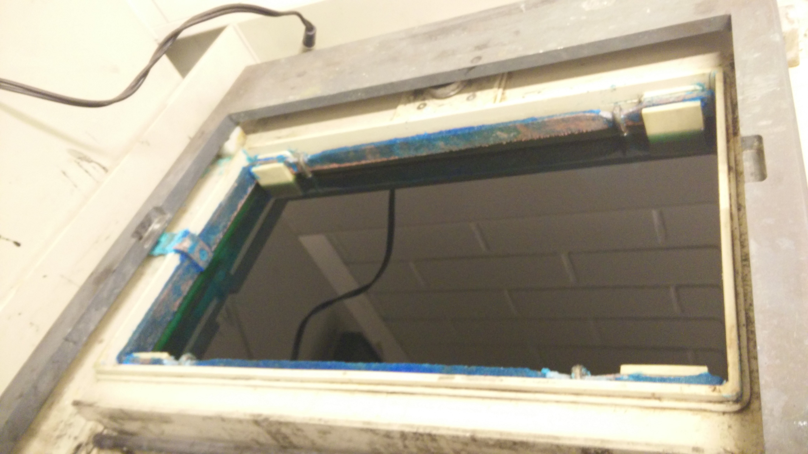

This is a process of approximately two hours. The best results are achieved with a low voltage   
(~ 0,5V) and a high current (~5A). The inside of the holes are now solid copper. This makes sure the connections are secure and the different layers and planes are connected to each other.

* + 1. Milling

Now it’s time to start milling. The plate is putted back in the machine and after calibration the mill will do his work. The PCB is milled layer by layer. It took around two and a half hours, for each layer, to mill the slave board (two layers). OAMK can construct PCB with up to 6 parted layers on one PCB.   
Looking to the milling process is like watching paint dry, but a little more amusing.

* + 1. Coating

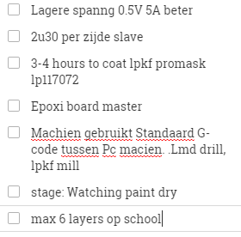

1. 3D modulating & printing

As a real ‘Finnishing’-touch I had the idea to put this prototype, and experience, to the maximum by designing and printing a box for the slave-boards at the university.

This was even after the final presentation and when I was the last member of the project still in Finland. We had a guided tour around the printers around March and I just couldn’t resist to ask them afterwards.

* 1. The design and software

When I contacted the staff that was responsible for this machines I asked them about the different software’s I could use and which one they recommend, because I never had 3D-printing experience before.

*Recommendation:* 3D CAD SolidWorks

*Other software:* AC3D Moi3D   
Blender Netfabb   
OpenScad 3D TinkerCad   
*All 3D-desining software that can export .stl files …*

After some sketches and test I came up with this final design for the Slave module:

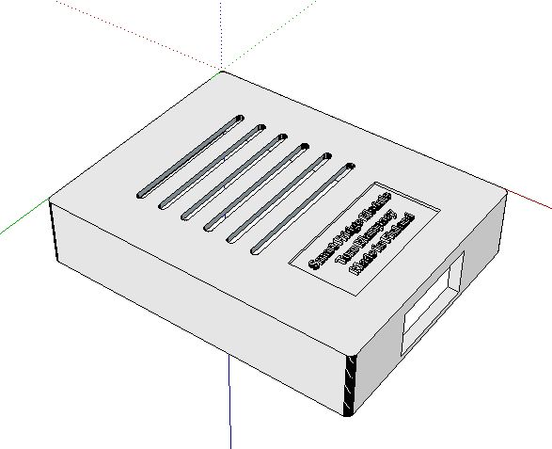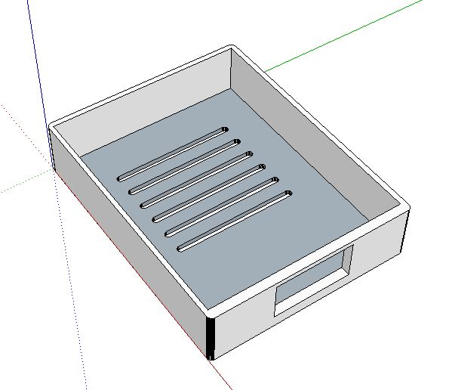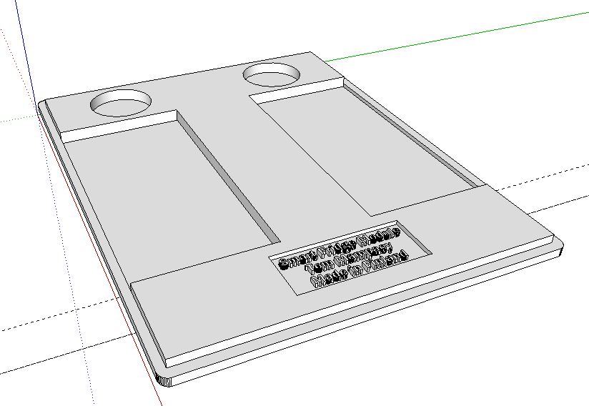

*Top view Bottom view Lit (bottom view)*

I made dilutions in lit of the box so the bright light of the RGB-LED can shine through. This gives a beautiful and clear color-effect around the product. Also the indication LEDS; power and reading, become visible for the user/developer by the round dilutions in the lit.

* 1. The Printers

OAMK has three amazing industrial 3D-printers. They even have one that they could take over of Nokia (laser 3D-printer, Nylon material). They use the printers for many purposes. From prototyping student projects to printing scanned human bones and skulls to prepare surgeons on medical operations. These printers are very professional with a high accuracy.

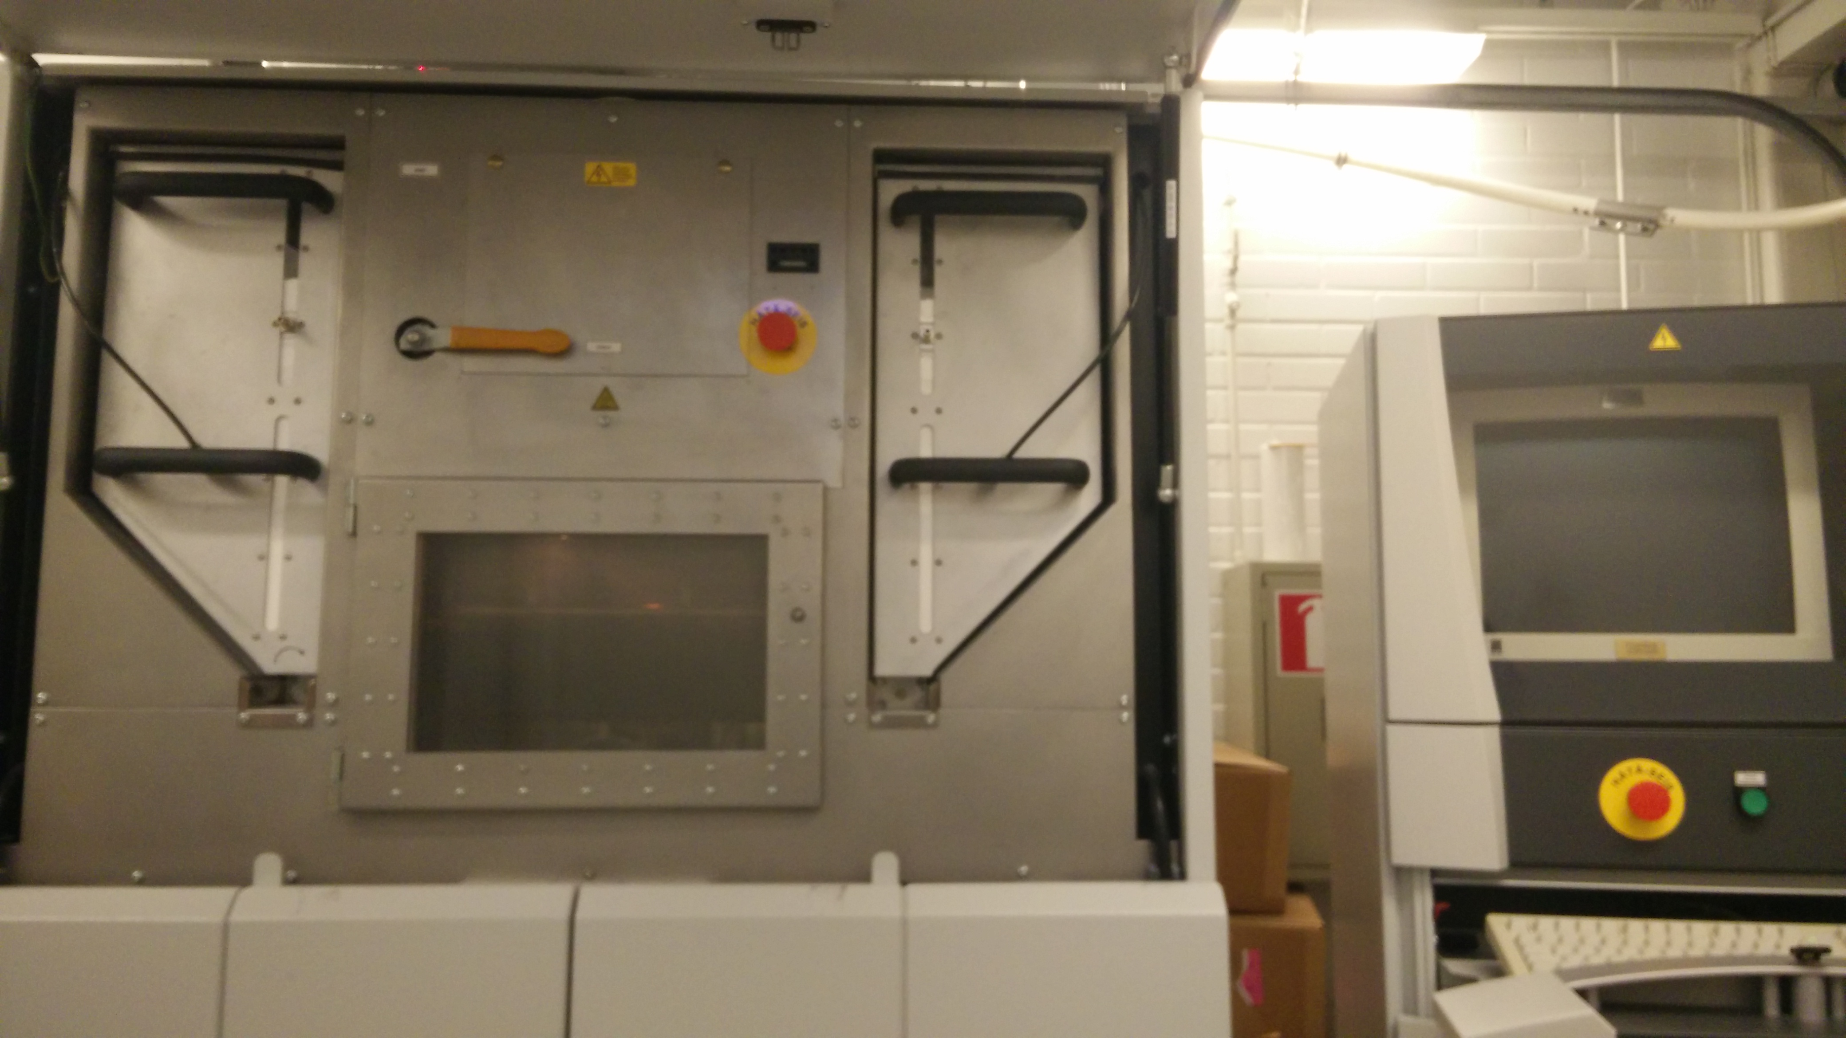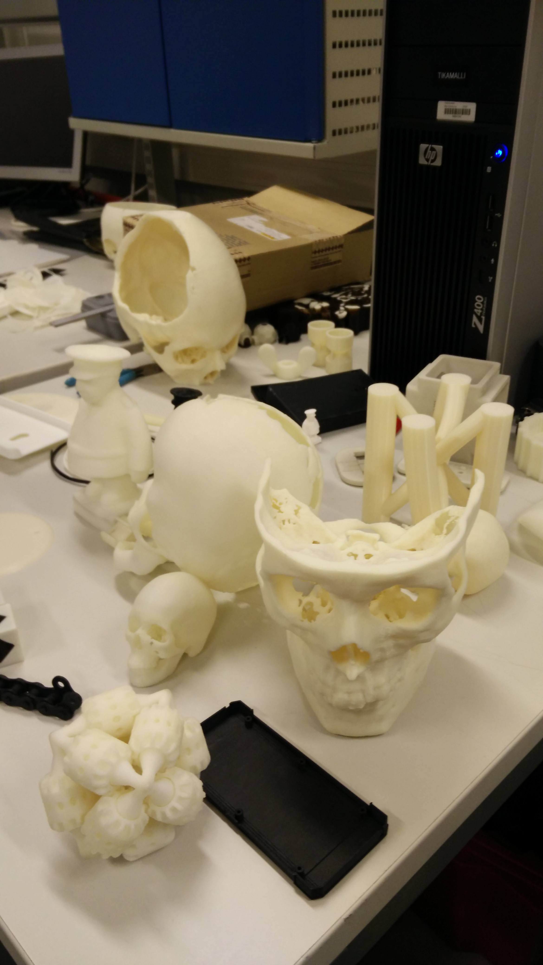

*EOSINT P380*

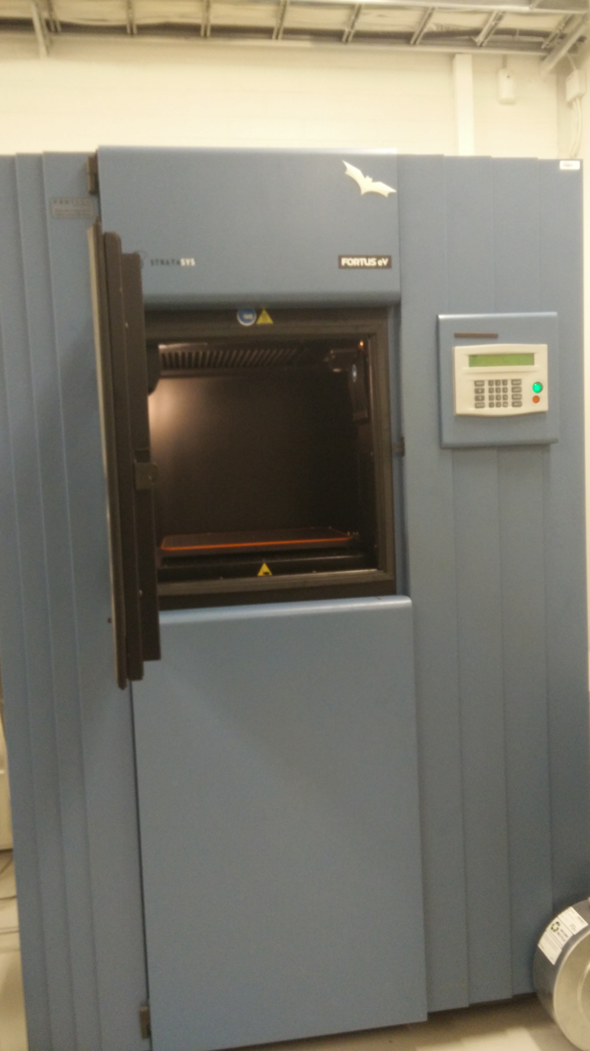

* + 1. Stratasys Fortus eV

The machine that fitted best for my prototype was the *Stratasys Fortus eV.* This is a very high quality printer that has different possibilities in colors and (support) materials. The material I used is white ABS M30 which is up to 25-70 percent stronger than standard Stratasys ABS and is an ideal material for conceptual modeling, functional prototyping, manufacturing tools, and end-use –parts.

* + 1. Details

Like you can see on the pictures bellow the boxes aren’t completely stuffed with the support material. We configured the machine with Smart Print which saves us support material that is added inside of the box to make in possible to print the bottom of the box on top.   
  
The support material can be removed by hand or by soaking it into water   
(or acid for faster result).

*Total volume for three boxes:* 174,5 cm³

*Price of materials:*  €0.30/cm³ (University) €0.50/cm³ (Customers)

*Estimated price for companies:* ~ €400

*Total duration of printing:* 36 hours (day and night)

* 1. Result, production, assembly

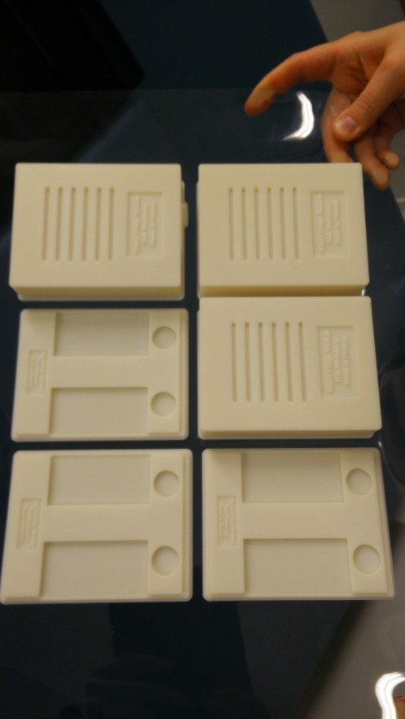After the first day printing I came back for observation and I was already very excited of how it looked. When it finally was ready and I removed all the support material my Slaveboard really fitted great, like they were made for it!

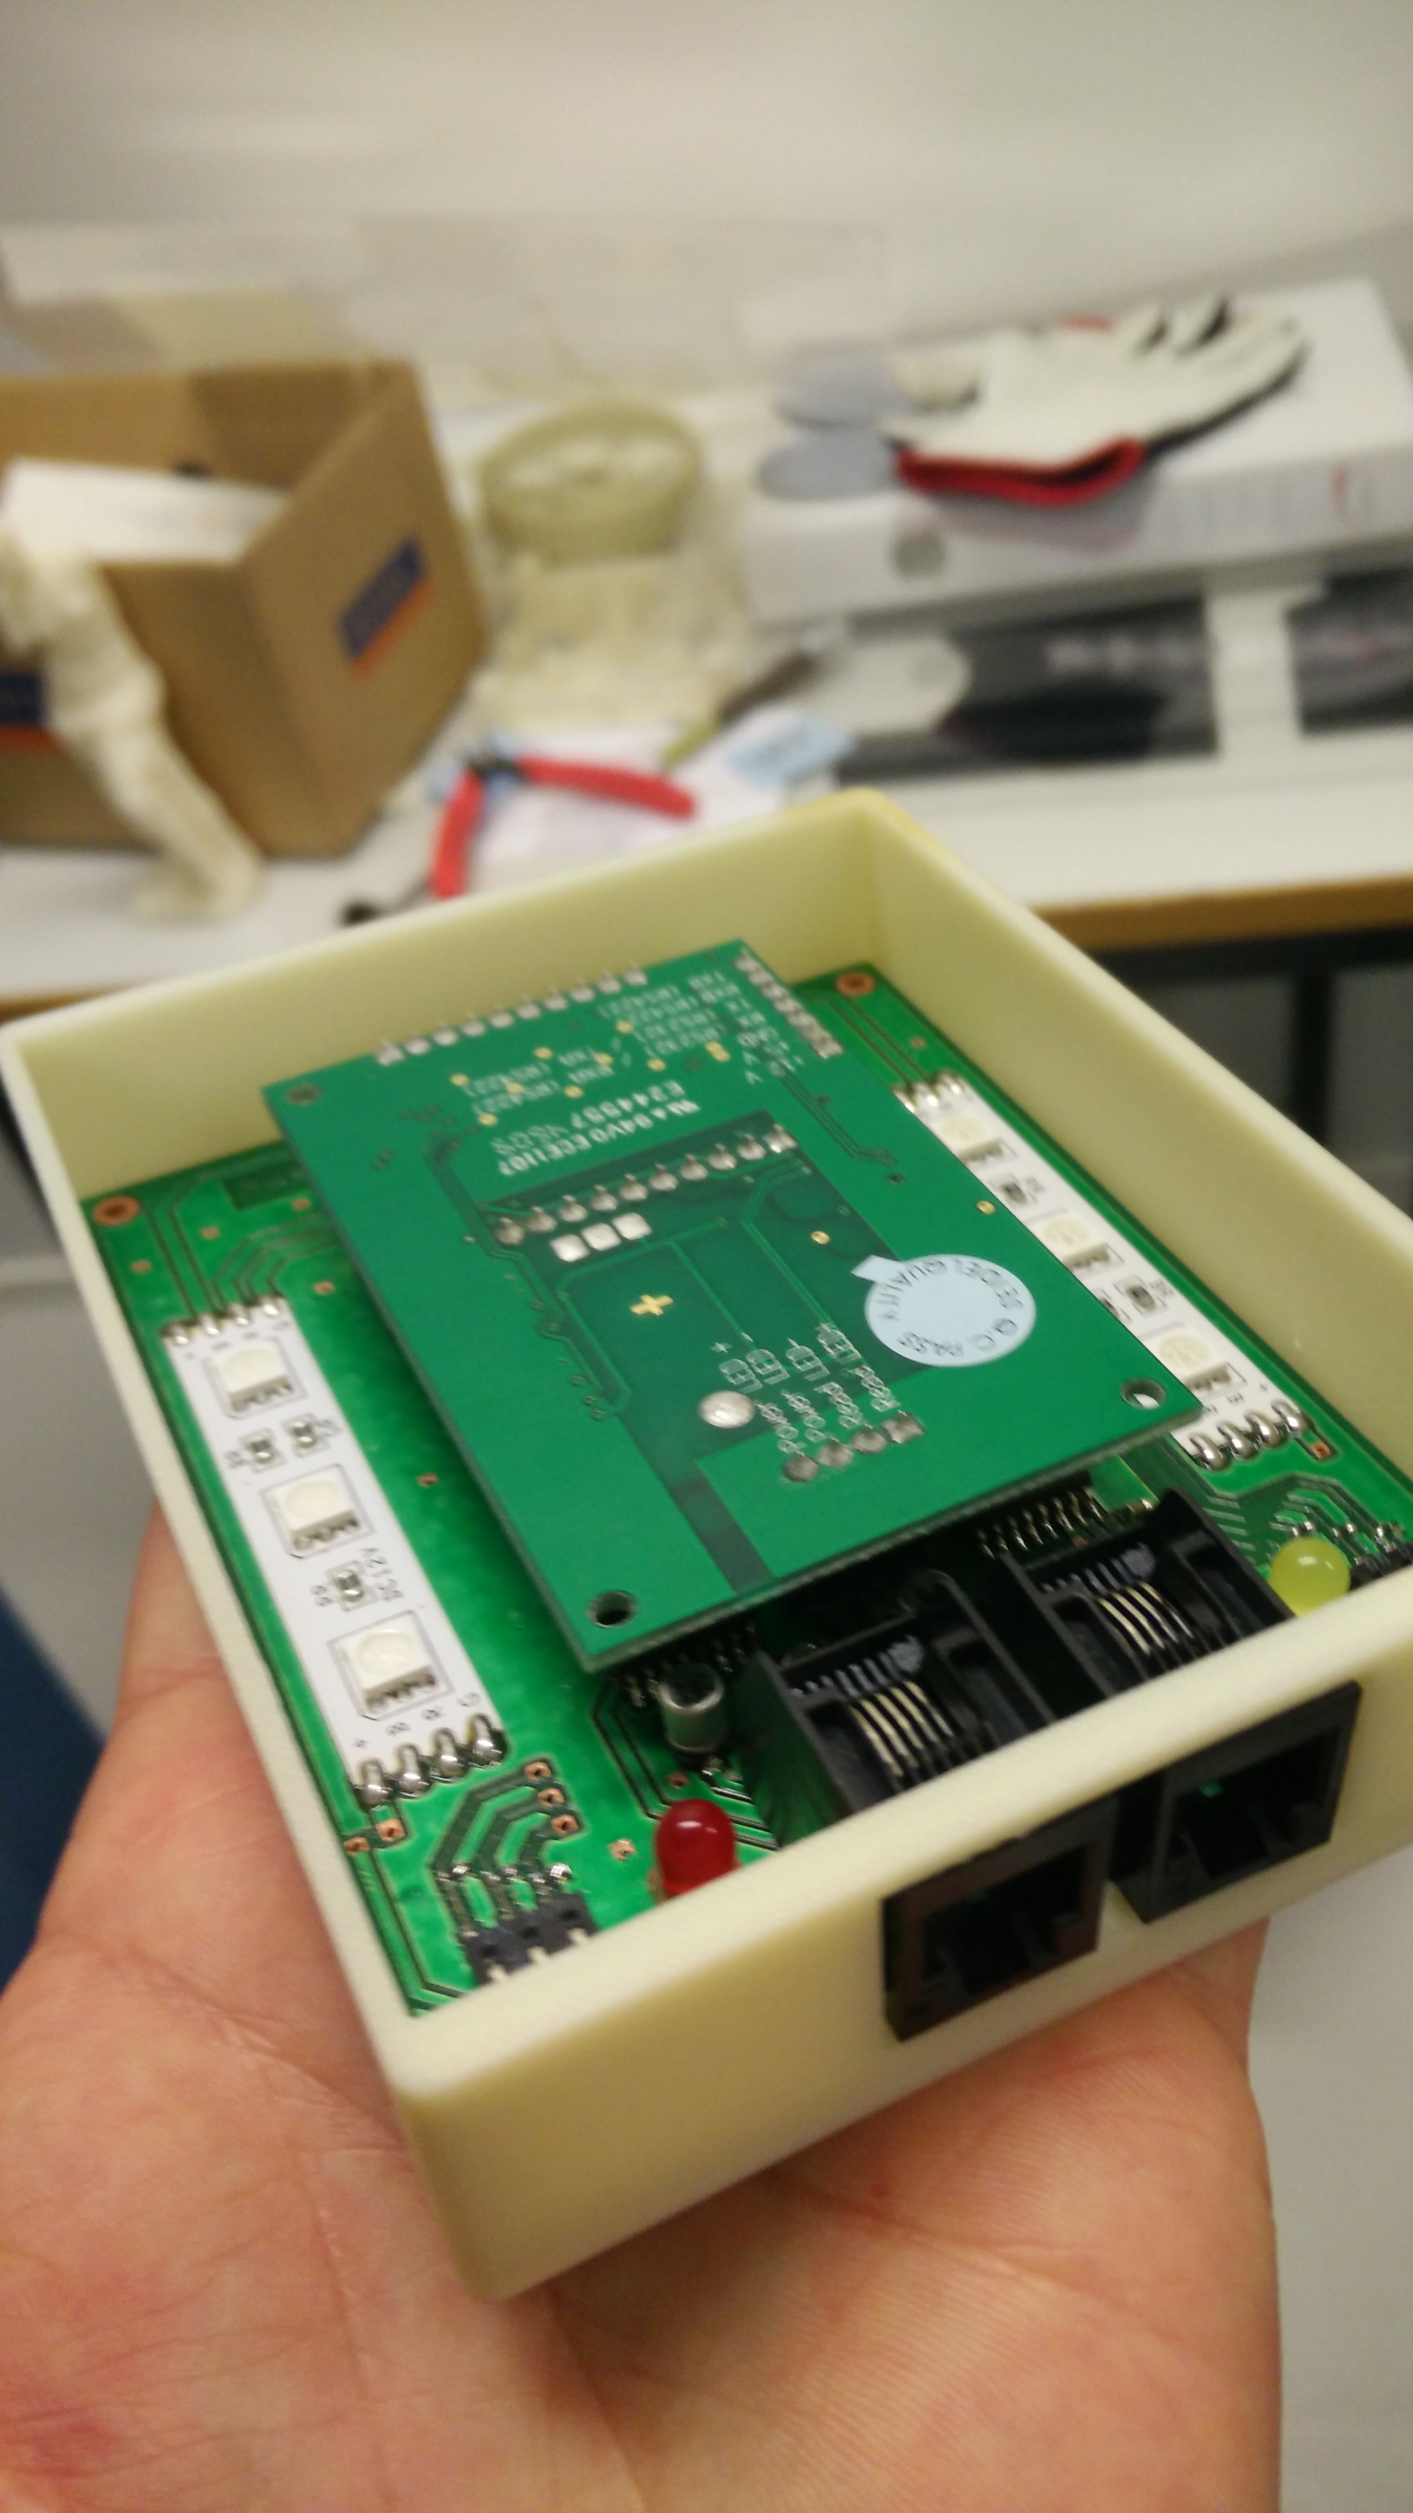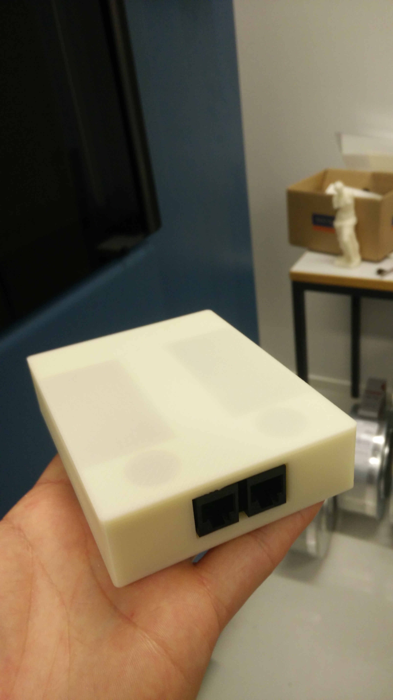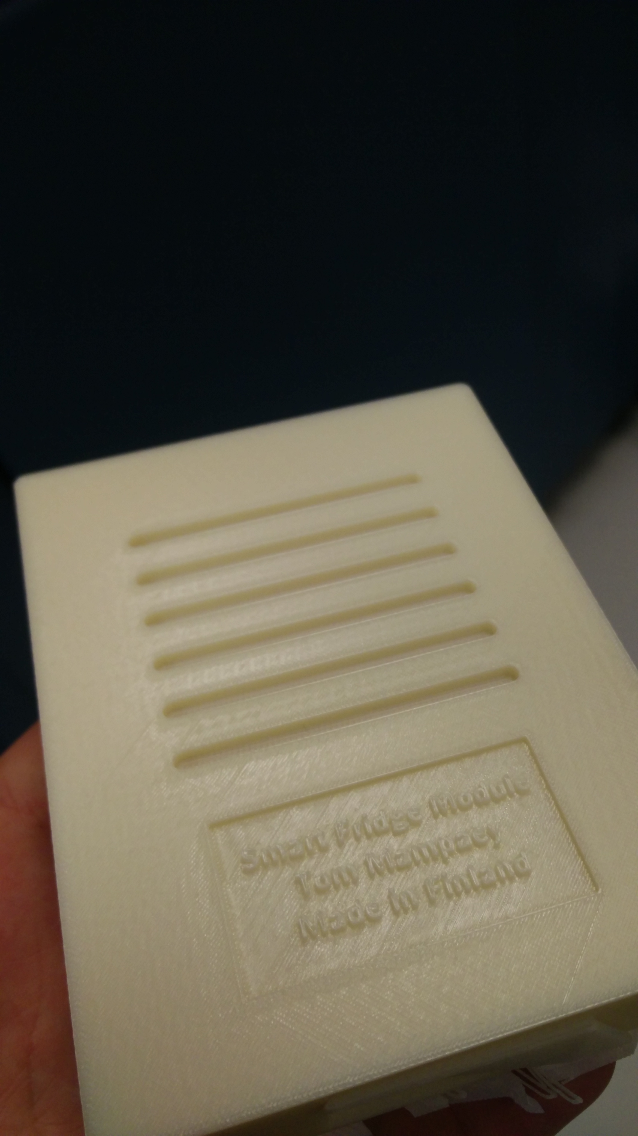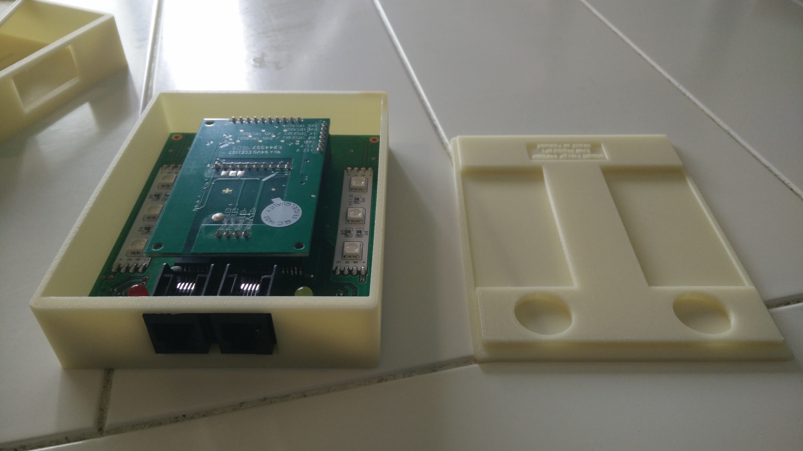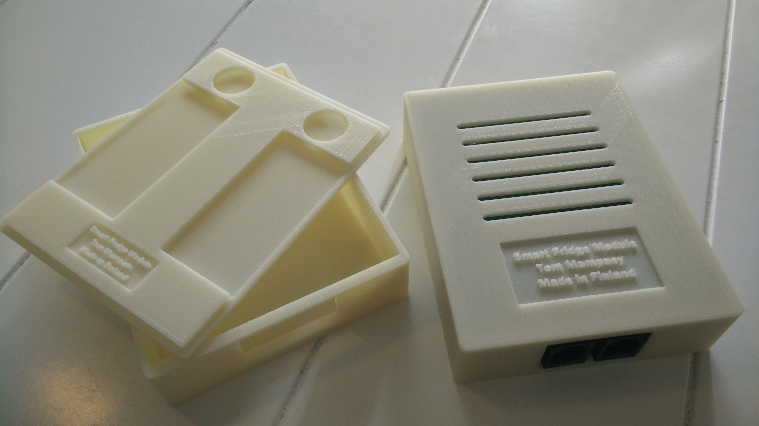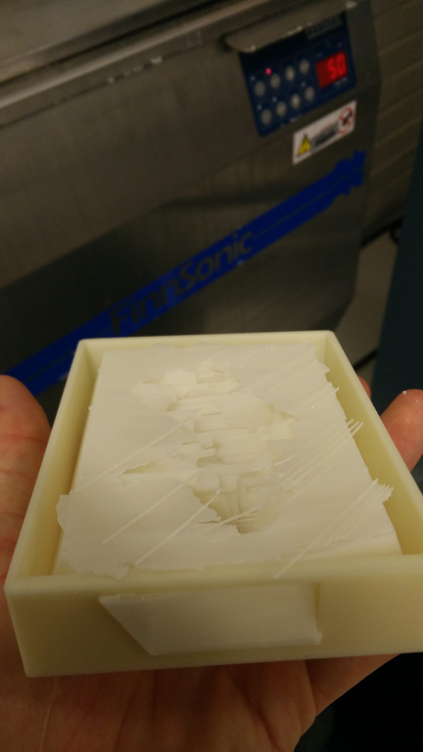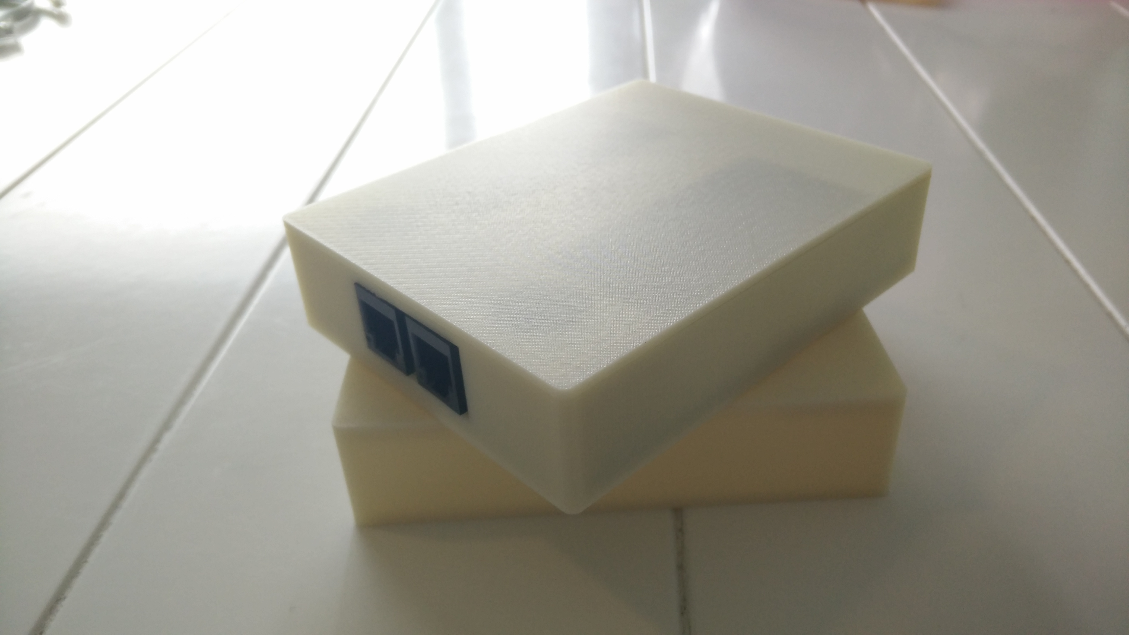

1. Personal project evaluation
   1. What I learned

Something very imported about a project is evaluate yourself on what you have learned during this project. When I think back at the beginning of the project I can say that I have learnt a lot due to this project, University and experience.

In the table above you can see a scale on what I have learned and which skills I improved.

*Note: Only applies to this project and independent of foreknowledge*

1. Optimalisations and further extensions

Blijven optimaliseren

1 IC PCF DIP,

Ony power reader when reading-command

Smaler

Scale,

Intigrate muliple NFC-redaers in shelfs of fridge.

Schema’s   
PCB process  
Troubles and solutions   
I2C   
What I learned  
WIFI  
SMD  
Sensors  
Internet of things  
Smart objects  
pie-diagram  
Algorithm!! (time swallowing)   
self-evaluation

Problems:  
//Time: Kinect, xTion, Scale, Motionsensor,… 3D-printing, Fault-analyzing/Debug, more problems than expected.   
Level convertsion. UART, MAX232  
Bus system, (took a while when finnaly up and running (stable)   
Interferences on powersuply, by antenna …

1. Of-topic:

Foto’s xtIon, Kinect

1. Concise self-evaluation

Internet of things  
Smart objects

The extraordinary thing about this project is that we got a blank paper,

This is very nice, but also takes a lot of extra time ofc.

We kunnen alvast zeggen dat onze opvolgers een uitgebreide basis hebbe .  
With the embeddedside and serverside working togheter We litterly van de anything now.

From now on everything is possible depending on the demand of the client.

What started at a kitchen in this school, is now reality!

Annex:

Content:

NFC:

* <https://developer.android.com/guide/topics/connectivity/nfc/index.html>
* <http://en.wikipedia.org/wiki/Near_field_communication>
* <http://www.digitaltrends.com/mobile/nfc-explained>
* <http://mashable.com/category/nfc>
* <http://www.identivenfc.com/en/what-is-nfc>
* <http://www.pcadvisor.co.uk/how-to/mobile-phone/what-is-nfc-how-nfc-works-what-it-does-3472879>

SRF05:

* <http://www.robot-electronics.co.uk/images/srf05p2.jpg>

Wi-Fi:

* <https://learn.sparkfun.com/tutorials/cc3000-hookup-guide/all>

PCB:

* <http://www.eurocircuits.com/clientmedia/ecImage/pages/electroless-copper-deposition/10%20electroless-copper-deposition_big.png>

3D Printing:

* OAMK University
* <http://en.wikipedia.org/wiki/List_of_3D_modeling_software>
* <http://www.redeyeondemand.com/abs-m30>
* <http://formlabs.com/company/press/formlabs-announces-draft-mode-and-smart-supports>

Datasheets:



Link:

Images:

* Front-page image:   
  <http://www.revistaexclusiva.com/?p=25851>

 [Supplementary](javascript:ALEXANDRIA_ENGINE.searchFromXsl('supplementary','en','en','nl','en');) component list: